

**Senior Design Project**

**The Design of AC – DC Converter Power Supply for Welding Machines**

ENGE476 Senior Design Project

Department of Engineering and Aviation Sciences

University of Maryland, Eastern Shore

**Iragena S. Bangamwabo**

Project Advisor, Dr. Lei Zhang

Submitted

December 12, 2018

List of Contents

List of Contents 2

List of Figures 2

List of Tables 3

Abstract 4

1. Introduction 5

1.1 Background/Motivation 5

1.2 Objective 6

1.3 Design Requirements 7

1.4 Design Constraints 7

1.5 Design Methods 7

2. Project Description 8

2.1 System Diagram 8

2.2 System Functions 9

3. Implementation Plan 10

3.1 Tasks 10

3.2 Team Organization 10

3.3 Timeline/Milestones/Delivery Plan 10

4. Implementation 12

4.1 Implementation of Task 1. Design of a Rectifier 12

4.1.1 Single Phase Rectifier 12

4.1.2 Three phase Rectifier 15

4.2 Implementation of Task 2 Design a DC-DC converter 18

4.2.1 Subtask 1. Buck-Boost Converter Analysis 18

4.2.2 Subtask 2. Transfer function 21

4.3 Implementation of Task 3 Control Unit for The Buck-Boost Converter 26

4.3.1 Subtask 1. Design of The Error Amplifier 27

4.3.2 Subtask 2. Design of Pulse Width Modulation 32

4.3.3 Subtask 3. Design of A Gate drive 34

4.4 Implementation of Task 5: Simulation of the Full Circuit 35

4.5 Implementation of Task 6: System Design Verification 37

4.6 Implementation of Task 7: Analyzing and Compiling Materials Needed 40

4.7 Implementation of Task 8: Design of The PCB 41

4.7.1 Importing the Schematic into the PCB Editor 42

4.7.2 Creating PCB and Layout 42

5. Hardware Assembly and Testing 47

6. Conclusion. 49

Acknowledgment 49

Appendix 50

REFERENCES 51

List of Figures

Fig. 1. System simplified into main tasks 8

Fig. 2. System Diagram of the circuit. 9

Fig. 3. Single phase rectifier with a low pass filter 13

Fig. 4. Spice simulation od single phase rectifier 14

Fig. 5. Input versus output graph before the low pass filter 14

Fig. 6. Input versus output graph After the low pass filter 15

Fig. 7. Three phase rectifier with the low pass filter 16

Fig. 8. Schematics of the buck-boost to be used 18

Fig. 9. Buck-boost converter with calculated values 24

Fig. 10. Input voltage vs output voltage 24

Fig. 11. Input current vs output current 25

Fig. 12. The input is 400V and Output obtained is 285 voltage 25

Fig. 13. Input current in green vs output current in blue 26

Fig. 14. Output voltage Simulation 27

Fig. 15. Type II Compensator with Gain Curve of Op-Amp 27

Fig. 16. Schematics of the error amplifier 28

Fig. 17. THE Output result of the error amplifier Simulation 29

Fig. 18. Voltage controlled oscillator (VCO) 33

Fig. 19. Output Simulations output of the VCO generating 34

Fig. 20. Design of the gate drive 34

Fig. 21. Simulation Output of the gate drive 35

Fig. 22. Systems’ circuit 36

Fig. 23. Simulation Output of the system 37

Fig. 24. Zoomed-in simulation Output of the system 37

List of Tables

Table 1 Project Timeline and Delivery Plan 10

Table 2 List of Materials Needed and Cost 46

Abstract

The purpose of this project is to solve a current issue that welders experience when using power tools that are currently available in the market. In many facilities, electrical power sources are of alternating current (AC) and many electrical devices rely on direct current (DC) which requires converting AC to DC. Though there are many ways of converting these power supplies from one source to another for low powered devices, converting alternating current to direct current in high powered devices is a challenge, thus our client needs an AC-DC power supply that takes a wide range of AC input voltages (from 120V to 600V) to supply a steady DC voltage.

In this project, the focus will be on the design, test and build a circuit that will fulfill this request and perform other functions required in the project overview. To achieve this, the project was divided into three sections. The rectifier, a voltage regulator and the control unit that uses the pulse width modulation technic. The rectifier will consist of a single phase and three phases full wave rectifier where the AC input power will be converted to DC voltage.

The output DC from the rectifier stage is set by the second stage of the block, a voltage regulator. The circuit will be able to maintain a constant DC voltage that is being supplied to the load and avoid possible damage to the machine. A commonly known method of voltage control is using a voltage regulator. A voltage regulator is used to regulate voltage level. When a steady, reliable voltage is needed, then the voltage regulator is the preferred device. It generates a fixed output voltage that remains constant for any changes in an input voltage or load conditions. The regulator will increase the voltage when it is less than 285 and decrease the voltage when it is greater than 285 volts. And then there will be a third section which is a control unit that uses a pulse width modulation system to control the triggering of the transistor gate. The on and off state will be applying output pulses of a specified width of either high or low when a suitable external trigger signal is applied.

1. Introduction

The end goal of this project is to develop an AC-DC power supply that takes a wide range of AC input voltages to supply a steady DC voltage to be used in welding machines. The AC input voltage range will be anywhere from 120V to 600V, single/three phase, with a frequency of 50Hz or 60Hz. The DC output voltage should be 285V at a maximum continuous current of 50A, or repetitive one-second surges of up to hundreds of current. A failure in the welder could draw a non-repetitive surge current from this supply, so the supply needs to either have a sufficient current rating to handle this surge until the circuit breaker trips or be able to monitor the output current and switch itself off before any components are damaged. Minimum load is 20mA.

## Background/Motivation

Electricity is a form of energy and it occurs in nature. There are two types of Electricity, Static Electricity, and Current Electricity. The Static Electricity is made by rubbing together two or more objects and making friction while Current electricity is the flow of electric charge across an electrical field. The second type (current) electricity is the main focus of the project. There are two types of electrical current: Direct current (DC) and Alternating current (AC). In a direct current; the electrons flow in one direction between two terminals while in alternating current electrical charges reverses directions periodically. The voltage in AC circuits also periodically changes due to the current changing directions. Since the invention of electricity, it has drastically transformed the way we live and has become vital to modern lifestyle. The ability to generate and distribute power was the main breakthrough followed by the invention of electronic and electrical devices. One such improvement was the development of power electronics. Power electronics is an area of electrical engineering that focuses on efficiently controlling the flow of electric energy by using solid-state switches and other electronics.

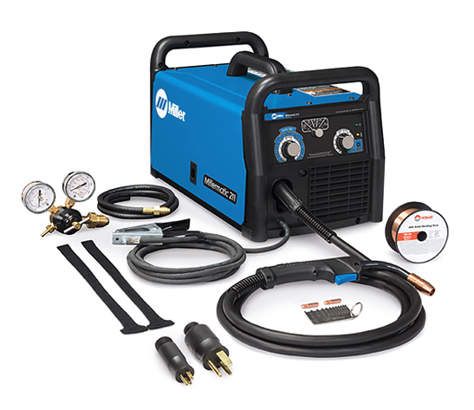

1. Typical welding machine. This one is from Miller Welders Supply Company

Power electronics are everywhere, over 40% of the world’s electric power generated utilizes power electronics systems. The emergence of switched-mode power supplies to replace large linear power supplies allowed advancement in a wide range of industries that now rely on power electronics [1]. The AC-DC converter that’s being developed to be used in a welder is an excellent example of the importance of power electronics. This circuit aims to achieve two objectives; the first objective is to convert an alternating current input to a direct current output without having an excessive power loss, this, in turn, would lead to high energy efficiency resulting in lower cost. Welders use electricity to melt the surfaces of the metals in order to join metals together through coalescence. The electricity is provided by a welding power supply that typically requires high currents, in this case, 50 amperes is required. In old welding power supplies, they consisted of transformers or engines driving generators that made them big and heavy making them very inconvenient to use. However, with technological advances, newer welding power supplies use semiconductors and microprocessors, reducing their size and weight. There are two ways to achieve this objective of converting the AC input to DC output. Can either use linear power converters which process the input power directly, with all active power conversion components operating in their linear operating regions, or use the switching power converters where the AC input power will be converted to DC pulses before processing by components that operate predominantly in non-linear modes (e.g., transistors that spend most of their time in cutoff or saturation). Power is "lost" (converted to heat) when components operate in their linear regions and, consequently, switching converters are usually more efficient than linear converters because their components spend less time in linear operating regions [2].

The second objective of the circuit is to be able to maintain a constant DC voltage that is being supplied to the load and avoid possible damage to the machine. A commonly known method of voltage control is using a voltage regulator. A voltage regulator is used to regulate voltage level. When a steady, reliable voltage is needed, then the voltage regulator is the preferred device. It generates a fixed output voltage that remains constant for any changes in an input voltage or load conditions. It acts as a buffer for protecting components from damages. A failure in the welder could draw a non-repetitive surge of up to 2267A from this supply, so the supply needs to either have a sufficient current rating to handle this surge until the circuit breaker trips or be able to monitor the output current and switch itself off before any components are damaged. For this objective, power electronics will be used. Components such as metal- oxide -semiconductor field-effect transistors (MOSFET), insulated-gate bipolar transistors (IGBTs) and rectifiers to control and convert the electric power to produce preferred power with respect to the desired application. The different types of power converters are rectifiers (AC-DC), inverters (DC-AC), AC-AC converters, and DC-DC converters. Rectifier and inverter circuits take one form of electric energy (AC or DC) and convert it to the other (DC or AC). AC-AC converters take AC power and convert it to a different level and/or frequency of AC power through circuit designs such as phase control and integral cycle control. DC-DC converters take DC power and convert it to different levels of DC power [1]. In addition, there is also Power Factor Circuit (PFC) that converts the universal AC input voltage to constant high-voltage DC and maintains the sinusoidal input current at high power factor.

## Objective

The objective of this project is to design an AC-DC power supply that takes a wide range of AC input voltages to supply a steady output DC voltage for a welding machine.

## Design Requirements

The following design requirements will be met upon completion of the project.

1. The AC input voltage range should be anywhere from 120V to 600V, single or three phases, 50Hz or 60Hz.
2. The DC output voltage should be 285V at a maximum continuous current of 50A.
3. It should fit in a size – 5’’ x 5’’ x 6’’
4. This power supply should be durable, handling voltage fluctuations and surges, and physical shocks.

## Design Constraints

In designing this power-supply circuit, the constraint in developing this project is under the following the conditions.

1. Budget- The budget is estimated to be $1000 based on the cost of materials, supplies, and equipment
2. Resources- Currently there is a limited resource available such as simulation software, and high voltage power source.

## Design Methods

The approach is to simplifier the project into small sections. First, a full-wave rectifier will be used to convert the alternating current (AC) into a direct current (DC) by allowing the current to flow through the load in the one direction during both negative and positive cycle. A full wave rectifier converts both polarities of the input waveform to pulsating DC (direct current) and yields a higher average output voltage. Two diodes and a center tapped transformer, or four diodes in a bridge configuration and an AC source (including a transformer without center tap), are needed [3].

Then design a DC-DC converter, the converter will be used to regulate the desired 285 voltage output. The buck-boost converter will be functioning as a switch mode DC-DC converter in which the output voltage will be transformed to a level less than or greater than the input voltage. The magnitude of output voltage will depend on the duty cycle of the switch.

The buck-boost converter is also called a step up/step down converter. The name steps up/step down converter comes from the fact that the output voltage can be stepped up/down to a level greater than or less than the input voltage. By the law of conservation of energy, the input power has to be equal to output power (assuming no losses in the circuit) [4]. In step-up mode, the input voltage is less than the output voltage; it follows then that the output current will be less than the input current.

Finally, a feedback control unit for the switch/transistor on the buck-boost converter will be designed. This control unit will take the system output into consideration, which enables the system to adjust its performance to meet the desired output response.

1. Project Description

The system is designed to generate a 14.4-kilowatt power supply that will operate on both single phase and three phase inputs, with emphasis on cost and reliability. The current generation of self-configuring power supplies is implemented with several input rectifier stages to enable the system to operate on most of the North American single and three phase line voltage standards. The self-configuration feature of this design automatically configures the input power subsystem to allow the power supply to operate on 120-240 volts single phase or 240, 380,415 and 575-volt three-phase power line. The reconfigurable input block power transmission matrix is implemented with a metal-oxide-semiconductor-field-effect transistor (MOSFET) switch.

## System Diagram

The 14.4-kilowatt input rectifier stage is highlighted in the system architecture of the welder power supply shown below. The focus of this project is the power supply input rectifier stage, DC-DC buck-boost converter, and the control unit. The functionality realized in the design is implemented in the proposed design via single-phase/ three-phase uncontrolled full-wave rectifier and a DC-DC converter.

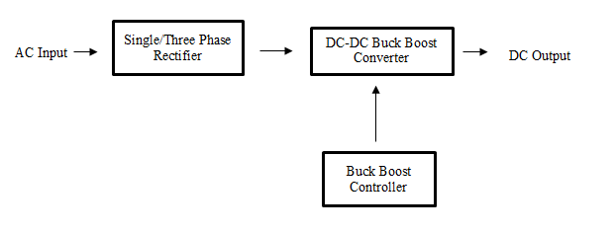

1. System simplified into main tasks

## System Functions

In Fig. 2 shown below, the single phase and three phases full wave uncontrolled rectifier are sampled by power diodes to generate the rectified DC voltage. The output DC from the rectifier stage is set by the second stage of the block, a DC-DC buck-boost converter for voltage control. The converter will increase the voltage when it is less than 285 and decrease the voltage when it is greater than 285 volts. And then there is a complementary block, a pulse width modulation system that will control the triggering of the transistor gate. The on and off state will be applying output pulses of a specified width of either high or low when a suitable external trigger signal is applied from the comparator.

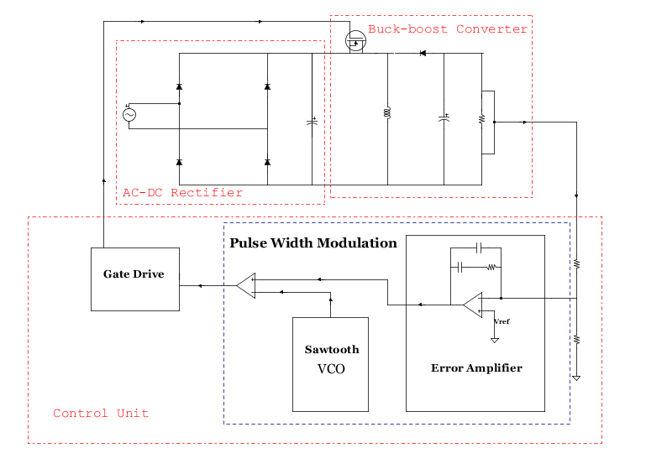

1. System Diagram of the circuit.
2. Implementation Plan

## Tasks

Below are the specified tasks and subtasks that need to be done to accomplish the project:

* Task 1. Design of an AC to DC Rectifier
* Task 2. Design of a DC-DC converter
  + Subtask 1. Buck-Boost Converter Analysis
  + Subtask 2. Transfer function
  + Subtask 3. Simulation
* Task 3. Design of a feedback control for the buck-boost converter
  + Subtask 1. Design of the Error Amplifier
  + Subtask 2. Design of a Pulse Width Modulation
  + Subtask 3. Design of a Gate driver
  + Subtask 4. Simulation of the gate driver
* Task 4. Design Verification
  + Subtask 1. Electronic simulation of the entire system
  + Subtask 2. Design Refinement
* Task 5. Design of a PCB
* Task 6. Prototype the Circuit

## Team Organization

All Tasks and subtasks are to be completed by Iragena Bangamwabo (Serge), for he is the sole team member working on this project.

## Timeline/Milestones/Delivery Plan

Below is a prospective timeline breakdown on how tasks were completed on weekly basis.

Table 1 Project Timeline and Delivery Plan

|  |  |  |  |
| --- | --- | --- | --- |
| **Time** | **Task** | **Comments** | **Responsible Personnel** |
| Week 1-3 | Task 1 | Design an AC-DC Rectifier. Look at the current methods used and available technologies | Iragena Bangamwabo |
| Week 4-6 | Task2 | Design a DC-DC converter | Iragena Bangamwabo |
| Week 6-7 | Subtask 1 &2 | Buck-Boost Converter Analysis and develop a transfer function | Iragena Bangamwabo |
| Week 8-9 | Task 4 | Design a feedback control loop for the power supply | Iragena Bangamwabo |
| Week 10-16 | Subtask 1,2 &3 | Design the compensator, design a pulse width modulation, design a Gate drive | Iragena Bangamwabo |
| Week 22 | Task 5 | Simulation of the full circuit | Iragena Bangamwabo |
| Week 23-25 | Task 6 | Double check the system design and Conduct further simulations | Iragena Bangamwabo |
| Week 26-28 | Task 7 | Analyze and review components needed for the prototype | Iragena Bangamwabo |
| Week 29-31 | Task 8 | Design the PCB and place an order for the materials | Iragena Bangamwabo |
| Week 31-32 | Task 9 | Test the prototype | Iragena Bangamwabo |

1. Implementation

## Implementation of Task 1. Design of a Rectifier

A rectifier is an electrical device composed of one or more diodes that convert alternating current (AC) to direct current (DC). This is achieved using semiconductors such as transistors and diodes.

A diode is like a one-way valve that allows an electrical current to flow in only one direction. A rectifier can take the shape of several different physical forms such as solid-state diodes, silicon-controlled and semiconductor switches [5].

### Single Phase Rectifier

For this particular design shown in figure 3, Power Diodes are connected together to form a full wave rectifier that converts AC voltage into pulsating DC voltage for use in the power supply.

* Reason for using Power diodes:

Power diodes are different from signal diodes; small signal diodes can also be used as rectifiers in low-power, low current (less than 1-amp) rectifiers or applications, but where larger forward bias currents or higher reverse bias blocking voltages are involved in the PN junction of a small signal diode would eventually overheat and melt, so larger more robust Power Diodes are used instead. A power diode is physically bigger, which means it requires more current to become operational. It has a much larger PN junction area compared to its smaller signal diode cousin, resulting in a high forward current capability of up to several hundred amps (KA) and a reverse blocking voltage of up to several thousand volts (KV) [6].

* The Rectifier:

The four diodes labeled D1 to D4 are arranged in series pairs with only two diodes conducting current during each half cycle. When the positive half cycle of the supply goes, D1, D2 diodes conduct in a series while diodes D3 and D4 are reverse biased and the current flows through the load. During the negative half cycle, D3 and D4 diodes conduct in a series and diodes D1 and D2 switch off as they are now reverse biased configuration.

* The Low Pass Filter:

Due to the high ripple effect of the DC output from the rectifier, smoothing capacitors are used to filter the output waveform in order to reduce this ripple. The LC filter also known as pi-filter shown in figure 3, will be used. This is comprised of the reservoir capacitor, C1, with a series inductor, L, and a second filter capacitor, C2 so that a steadier DC output can be obtained across the terminals of the final filter capacitor. The series inductor presents a high impedance at the ripple current frequency.

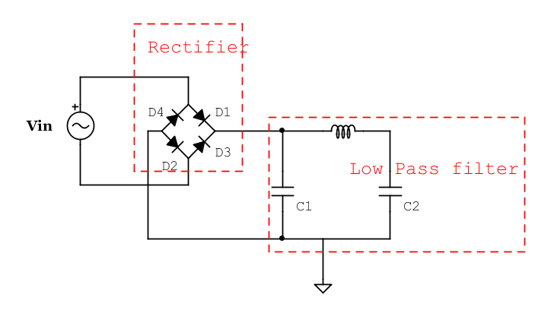

1. Single phase rectifier with a low pass filter

The rectifier operating in dc steady state under the following conditions:

$V_{AC} = 120V_{RMS}$, $P_{o} = 14.4KW$,

$Δi_{L} = 20A$, $ΔV_{p-p}=100mV$ and $f_{S} = 200kHz$.

The value of the smoothing capacitor can is calculated as:

$$Q =I_{o}×DT_{s} = 50.526×3.132×{10}^{-6} = 158.247μC$$

If the peak-peak output voltage ripple is $100.0mV$, therefore the circuit capacitors value is

$$C_{1}=C_{2}= \frac{Q}{ΔV_{p-p}} = \frac{158.247×{10}^{-6}}{100×{10}^{-3}}F = 1.583×{10}^{-3}F = 1583μF$$

The peak amplitude of the source voltage can be calculated as:

$$V_{m}=\sqrt{2}*120=169.7V$$

For this rectifier shown in figure 4, the smoothing capacitors are the aluminum m electrolytic type that has a capacitance value of 40uF or more with repeated DC voltage pulses from the rectifier charging up the capacitor to peak voltage.

The selected power diodes that meet the parameters for this circuit are VS-1N1183A, manufactured by Vishay Semiconductors. The data sheet will be attached for reference. Here is the circuit simulation conducted using the linear technologies’ spice model to observe the rectifier’s performance. In order to convert the AC Voltage to DC voltage, a full wave rectifier is used. A Full Wave Rectifier is a circuit, which converts AC voltage into a pulsating DC voltage using both half cycles of the applied AC voltage. It uses two diodes of which one conducts during one-half cycle while the other conducts during the other half cycle of the applied AC voltage [4]. This Single phase rectifier uses four individual rectifying diodes connected in a closed loop bridge configuration to produce a DC output.

Although four individual power diodes are used to make the rectifier, pre-made rectifier components (chips/microcontrollers) are available in different stores in a range of different voltage and current sizes that can be soldered directly into the PCB circuit.

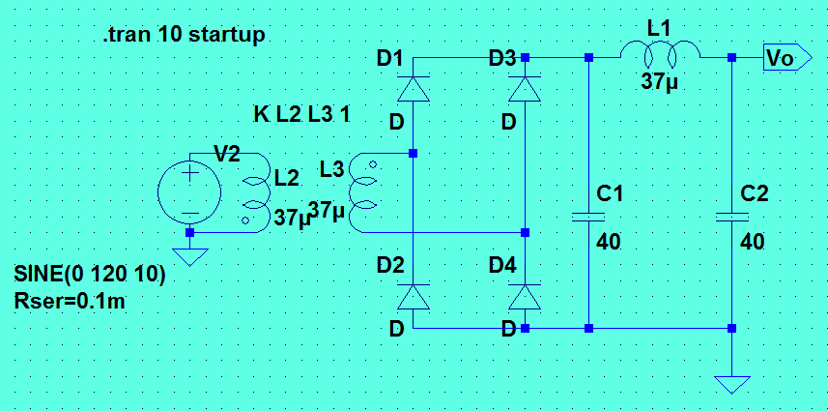

1. Spice simulation od single phase rectifier

And the simulation results can be observed below in figure 5 and figure 6. The top blue graph represents the full wave rectified DC output voltage from the rectifier before it is filtered through the low pass filter while the bottom green graph represents the input AC voltage.

Figure 6 still shows the AC input voltage in the top blue graph and the output DC voltage in green after the smothering low pass filter.

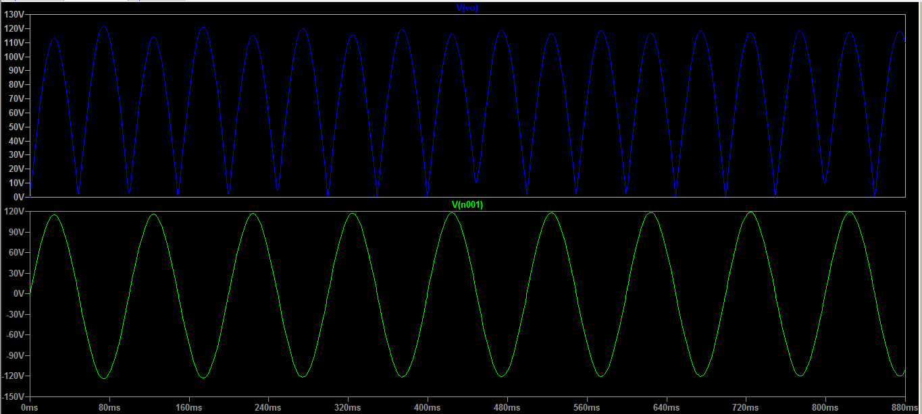

1. Input versus output graph before the low pass filter

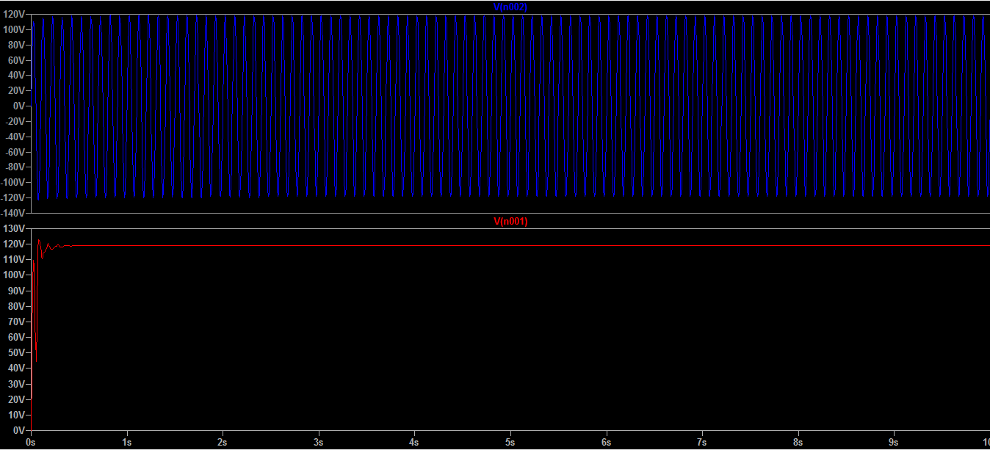

1. Input versus output graph After the low pass filter

### Three phase Rectifier

The working principles of a three-phase rectifier are similar to those of the single-phase rectifier. In three phases full wave rectifier six diodes are used to convert a three-phase AC voltage at the input to a DC voltage at the output. The DC voltage is divided into six segments within one fundamental source period that corresponds to the different line-to-line source voltage combinations. In each segment, there is a minimum and maximum DC voltage [8]. Minimum DC voltage is when one line-to-line voltage is zero, Maximum DC voltage is when two line-to-line voltages are equal. In between the minimum and maximum dc voltages lies the average DC voltage

In Figure 7, Each three-phase line connects between a pair of diodes; one to route power to the positive (+) side of the load, and the other to route power to the negative (-) side of the load. Here the output current flows through one diode of the upper group and one diode of the lower group of diodes. If a node of a diode is at a high potential, this upper group diode will conduct while other two diodes are reversed biased. Similarly, the diode having the cathode at lower potential will conduct while the other two diodes are off. The diode pair’s conduction for above circuit is given as D6 D1, D1 D2, D2 D3, D3 D4, D4 D5, and D6 D1. Since one diode from the upper group and one diode from the lower group are always conducting; negative members of three-phase voltages are rectified, so the output voltage consists of six segments of line voltage during one cycle.

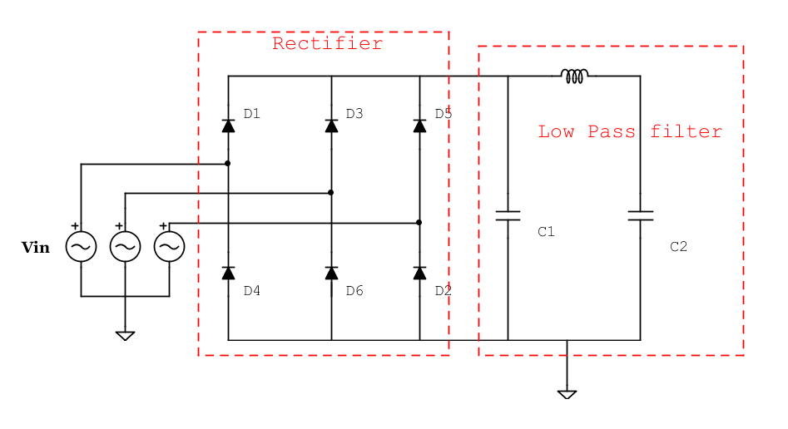

1. Three phase rectifier with the low pass filter

* Analysis of 3 phase rectifier with resistive load:

Notation: Let Vm = Peak line to neutral voltage

$=V_{rms}=230*\sqrt{2}=325.2Vm$

Useful Integration formula:

$\int_{\frac{-π}{6}}^{\frac{π}{6}}{\cos^{2}\left(ωt\right)dωt=\frac{π}{6}}+\frac{\sqrt{3}}{4}$

Peak Output Voltage = peak of the line of line voltage

$=\sqrt{3}*V_{m}$

Average Value of the output voltage may be obtained by averaging over a single

Output pulse and using the fact that the output voltage follows a line to line voltage waveform for each pulse.

$V_{0}=\frac{\int_{-\frac{π}{6}}^{\frac{π}{6}}{\sqrt{3}*V_{m}\cos\left(ωt\right)dωt}}{\frac{2π}{6}}$

$=\frac{3\sqrt{3}}{π}*V_{m}=380V$

Since the output current for a resistive load is just VO (t)/R we can now calculate the

Rectification ratio (efficiency)

$\frac{V_{0}I_{0}}{V_{0(rms)}I_{0(rms)}}=\frac{{V0}^{2}/R}{{V(rms)}^{2}/R}$

$=\frac{(\frac{3\sqrt{3}}{π})^2}{(V_{m}\sqrt{\frac{3}{2}+\frac{9\sqrt{3}}{4π}})^2}V_{m}=0.96$

In order to calculate the ripple factor, we must extract the ac component from VO

Using the relationship:

$$V_{o\left(ac\right)}=\sqrt{{V^{2}}_{o\left(rms\right)}-{V^{2}}_{o}}$$

$$Ripple factor =\frac{V_{o\left(ac\right)}}{V_{0}}=\frac{\sqrt{{V^{2}}_{o\left(rms\right)}-{V^{2}}_{o}}}{V_{0}}=\sqrt{\frac{{V^{2}}_{o\left(rms\right)}}{{V^{2}}_{o}}-1}=\sqrt{\frac{1}{0.96}-1}=0.06=6\%$$

* Spice model simulation:

The configuration used in single phase rectifier is the same use in three phases with the addition of an extra line phase. Similarly, the same power diodes used in the single phase are also used here. They are huge power diodes and have the metal body for better cooling compared to regular signal diodes. In addition, they are a bit costly and requires more space because they are generally fitted heatsink.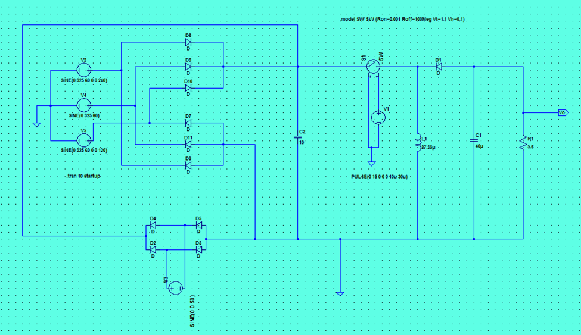

1. Ltspice Three phase Configuration

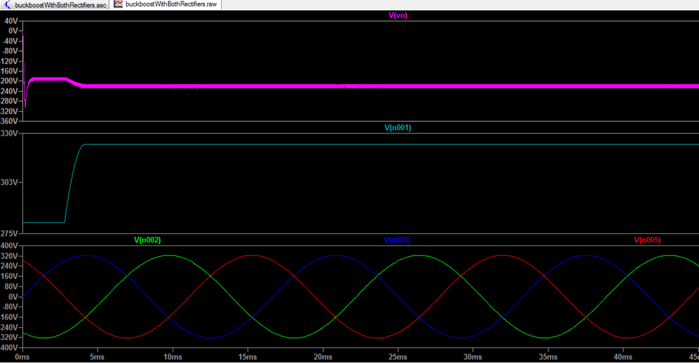

1. The line to line voltage

## Implementation of Task 2 Design a DC-DC converter

Once a dc voltage is generated from the rectifier, a buck-boost converter will be needed to achieve an output voltage magnitude that is either greater than or less than the input voltage. In order to maintain the desired output of 285 Vdc, a buck-boost converter is used for that purpose.

### Subtask 1. Buck-Boost Converter Analysis

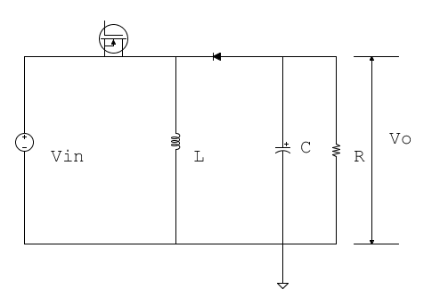

1. Schematics of the buck-boost to be used

Simplified Model of the Buck-Boost Converter

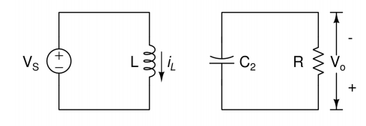

1. Buck-Boost Converter Model for T on

First, we examine when T is on

$-{V }_{s} + L \frac{{di}_{L }}{dt} = 0$

Therefore,

$i_{l} (t ) = \frac{V_{ S}}{L} (t-t_{ 0})+ iL(t 0) , for t 0≤t≤DT$

$C2 \frac{dVo }{dt }+ \frac{V o }{R }= 0$

Hence

$Vo \left(t\right)= Vo \left({t }_{0} \right){e }^{-\frac{\left(t-{t }_{0} \right)}{RC2}} , for t 0≤t≤DT$

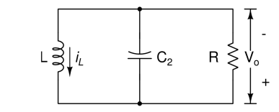

1. Buck-Boost Converter Model for T off

$$-{i }_{L}+ \frac{Vo}{R} + C \frac{dVo}{dt} = 0$$

Therefore,

$$\frac{{d }^{2}Vo}{dt^{ 2}} + \frac{1}{RC} \frac{ dVo}{dt} + \frac{Vo }{LC }= 0$$

$$V_{o}(s) [{ s}^{2} + \frac{s}{RC2} + \frac{1 }{LC2} ] = 0$$

And

$$s = - \frac{1}{{2RC}_{2} } ± \sqrt{{( \frac{1 }{{2RC}_{2}} )}^{2 }- \frac{1 }{LC2}}$$

Now let's consider the case for over-damped, i.e.

$$R<\frac{1 }{2}\sqrt{\frac{L}{C2 } }$$

Therefore,

$$V_{o}(t) ={ A}_{0} e^{s_{1} t } + A_{2} e^{s_{2} t} for DT <t<T$$

Where,

$$s1=-\frac{ 1}{2 {RC}_{2}} + \sqrt{{( \frac{1}{2 {RC}_{2}} )}^{2 } - \frac{1}{ LC2}}$$

$$s2=-\frac{ 1}{2 {RC}_{2}} - \sqrt{{( \frac{1}{2 {RC}_{2}} )}^{2 } - \frac{1}{ LC2}}$$

And,

$$V_{o}(0) = A_{0} + A_{1}$$

And

$$\frac{dVo}{dt } = s_{1} A_{0 }e^{s_{1} t } +s_{2} A_{1 }e^{s_{2} t }$$

Therefore,

$$\frac{i_{L} (0)}{C_{2} } - \frac{Vo (0)}{RC_{2}} =s_{1} A_{0 } +s_{2} A_{1 }$$

Hence,

$$A_{0} =\frac{\frac{i_{L} (0)}{C_{2} }-Vo (0)(\frac{1 }{RC2}+s_{2})}{s_{2}-s_{1}}$$

$$A_{1} =\frac{\frac{i_{L} (0)}{C_{2} }-Vo (0)(\frac{1 }{RC2}+s_{1})}{s_{2}-s_{1}}$$

Finally,

$$i_{L} \left(t\right)= \left( \frac{1}{R }+s_{1}c_{2}\right)A_{0 }e^{s_{1} t } + \left( \frac{1}{R }+s_{2}c_{2}\right)A_{1 }e^{s_{2} t } , for DT <t≤T$$

Using on T values for initial conditions,

$$A_{0}=\frac{\frac{\frac{V_{S} }{L} DT +i_{L}(0)}{C_{2}}-Vo (0){e }^{\frac{-DT}{RC2}} (\frac{1 }{RC2}+s_{2})}{s_{2}-s_{1}}$$

$$A_{1}=\frac{\frac{\frac{V_{S} }{L} DT +i_{L}\left(0\right)}{C_{2}}-Vo \left(0\right){e }^{\frac{-DT}{RC2}} \left(\frac{1 }{RC2}+s_{1}\right)}{s_{2}-s_{1}}$$

Thereof

$$V_{o} \left(0\right)=\left[\frac{\frac{\frac{V_{S} }{L} DT +i_{L}(0)}{C_{2}}-Vo (0){e }^{\frac{-DT}{RC2}} (\frac{1 }{RC2}+s_{2})}{s_{2}-s_{1}}\right]+ \left[\frac{\frac{\frac{V_{S} }{L} DT +i_{L}(0)}{C_{2}}-Vo (0){e }^{\frac{-DT}{RC2}} (\frac{1 }{RC2}+s_{1})}{s_{2}-s_{1}}\right]$$

### Subtask 2. Transfer function

The Buck-boost small-signal transfer function is,

$$\frac{\tilde{v_{o}}}{\tilde{d}}=\frac{V_{in}}{L_{e}C{\left(1-D\right)}^{2}}\left(1-s\frac{DL_{e}}{R}\right)\frac{1+srC}{s^{2}+s\left(\frac{1}{RC}+\frac{r}{L_{e}}\right)+\frac{1}{L_{e}C}}$$

Where,

$$L_{e}=\frac{L}{{\left(1-D\right)}^{2}}$$

And the equivalent series resistance (ESR) $r=0.1Ω$

$$H\left(jω\right)=\frac{V_{in}}{L_{e}C{\left(1-D\right)}^{2}}\frac{\left(1+ω^{2}\frac{rDL_{e}C}{R}\right)+jω\left(rC-\frac{DL_{e}}{R}\right)}{\left(\frac{1}{L_{e}C}-ω^{2}\right)+jω\left(\frac{1}{RC}+\frac{r}{L_{e}}\right)}$$

Therefore,

$$\left|H\left(jω\right)\right|=\frac{V_{in}}{L_{e}C{\left(1-D\right)}^{2}}\frac{\sqrt{{\left(1+ω^{2}\frac{rDL_{e}C}{R}\right)}^{2}+ω^{2}{\left(rC-\frac{DL_{e}}{R}\right)}^{2}}}{\sqrt{{\left(\frac{1}{L_{e}C}-ω^{2}\right)}^{2}+ω^{2}{\left(\frac{1}{RC}+\frac{r}{L_{e}}\right)}^{2}}}$$

And,

$$θ=\tan^{-1}\left[\frac{ω\left(rC-\frac{DL_{e}}{R}\right)}{\left(1+ω^{2}\frac{rDL_{e}C}{R}\right)}\right]-\tan^{-1}\left[\frac{ω\left(\frac{1}{RC}+\frac{r}{L_{e}}\right)}{\left(\frac{1}{L_{e}C}-ω^{2}\right)}\right]$$

A Buck-Boost converter and full-wave rectifier power supply is shown in Fig 9. The converter operating in dc steady state under the following conditions: $V_{AC}= 120V_{RMS}$, $V_{o} = 285V$, $P_{o} = 14.4KW$, $Δi_{L}=20A$, $ΔV_{p-p}=100mV$ and $f_{S} = 200kHz$. Assuming ideal components, calculate *L, C2* and *RL*.

Therefore,

$$\frac{285}{170} = \frac{D}{1-D}$$

Hence,

$$\begin{matrix}D & = & \frac{285}{285+170} \\ & = & \frac{285}{455} \\ & = & 0.626\end{matrix}$$

The switching period is,

$$T_{S} = \frac{1}{f_{s}} = \frac{1}{200×{10}^{3}} = 5μs$$

And,

$$T_{on} = DT_{s} = 3.132μs$$

The value of the inductor in the converter is,

$$L = \frac{V_{in}}{Δi_{L}}DT_{s} = 26.621μH$$

The average input current is,

$$I_{in} = \frac{P_{in}}{V_{in}} = \frac{14.4kW}{170V} = 84.706A$$

And the average output current is,

$$I_{o} = \frac{P_{o}}{V_{o}} = \frac{14.4kW}{285V} = 50.526A$$

Therefore the average inductor current is

$$\begin{matrix}I_{L} & = & I_{in} + I_{o} \\ & = & 84.706A + 50.526A \\ & = & 135.232A\end{matrix}$$

The average diode current is,

$$I_{diode} = I_{o} = 50.526A$$

When the transistor is on, the diode current is zero and,

$$i_{c} = -I_{o} = -50.526A$$

The capacitor current jumps to a value of

$$i_{C_{max}} = I_{in} + \frac{Δi_{L}}{2} = 84.706A + 10A = 94.706A$$

And drops to

$$i_{c} = I_{L} - \frac{Δi_{L}}{2} - I_{o} = 135.232A-10A-50.526A = 74.706A$$

The load resistance is,

$$R_{L} = \frac{V_{o}^{2}}{P_{o}} = \frac{{\left(285V\right)}^{2}}{14.4kW} = 5.64Ω$$

The total charge on the capacitor is over $T_{on}$,

$$Q =I_{o}×DT_{s} = 50.526×3.132×{10}^{-6} = 158.247μC$$

If the peak-peak output voltage ripple is $100.0mV$ the circuit capacitor value is

$$C_{2} = \frac{Q}{ΔV_{p-p}} = \frac{158.247×{10}^{-6}}{100×{10}^{-3}}F = 1.583×{10}^{-3}F = 1583μF$$

The circuit model shown below will be used for a SPICE simulation of the Buck-boost switch-mode power supply.

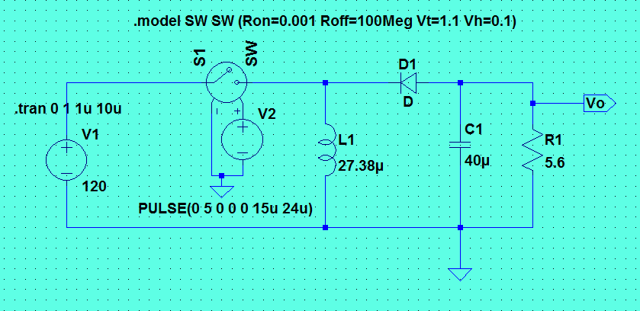

1. Buck-boost converter with calculated values

The simulation results can be observed below in figure 10 and figure 11. The top blue graph represents the DC output voltage from the buck-boost converter the bottom green graph represents the input DC voltage to the converter. As can be seen; the goal of achieving 285volts output was achieved. Figure 16, shows the input current in the bottom green graph and the output current in the top blue which is approximately 50A, also achieving the desired output current.

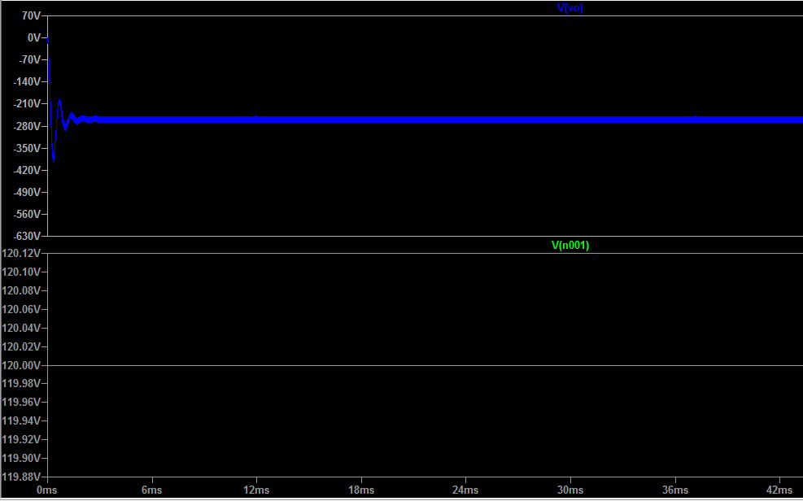

1. Input voltage vs output voltage

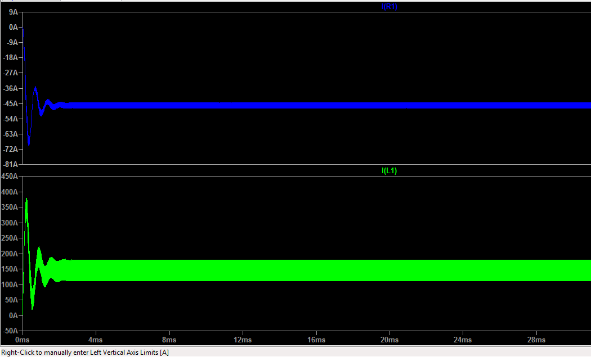

1. Input current vs output current

Another simulation was done with different input (400 volts) and the SPICE simulation results are shown below.

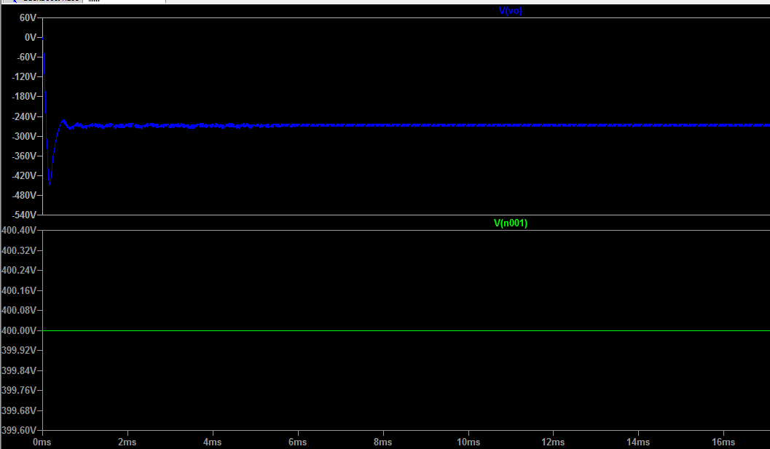

1. The input is 400V and Output obtained is 285 voltage

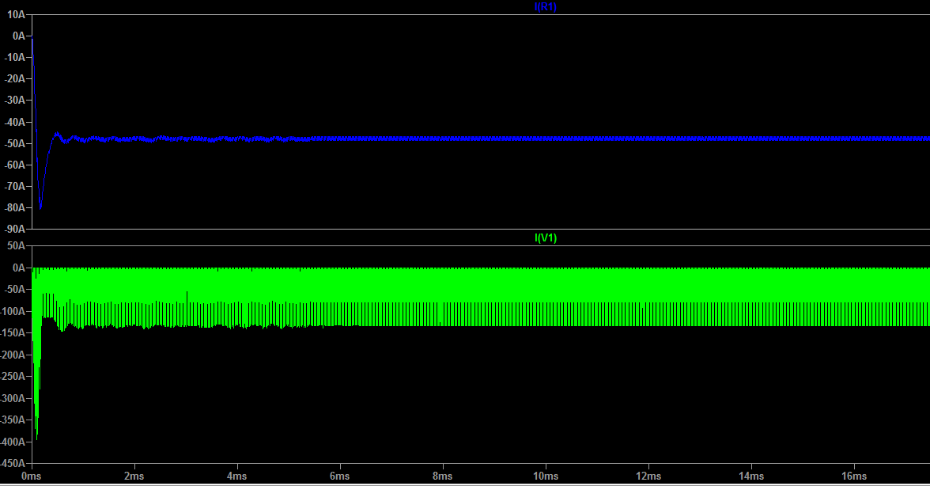

1. Input current in green vs output current in blue

## Implementation of Task 3 Control Unit for The Buck-Boost Converter

In this figure 14, the inner feedback unit is an input-current feedback while the outer one is an output-voltage feedback unit. The current loop makes the line current follow a reference signal, which is obtained by multiplying a rectified sinusoidal waveform obtained from the line voltage by the control signal. Thus, the line current is a sinusoid whose amplitude is determined by the value of the voltage from the error amplifier. The standard design of the voltage feedback loop implies low ripple in. This is because a relatively high ripple would cause considerable distortion in the reference of the line current feedback loop, and hence in the line current. To have low ripple on the control signal, the bandwidth of the compensator must be relatively low. It leads to a low bandwidth in the entire output-voltage feedback loop. This low bandwidth limits the transient response of the power supply. The transient response of a power supply under these conditions is fast enough to satisfy the requirements of the load.

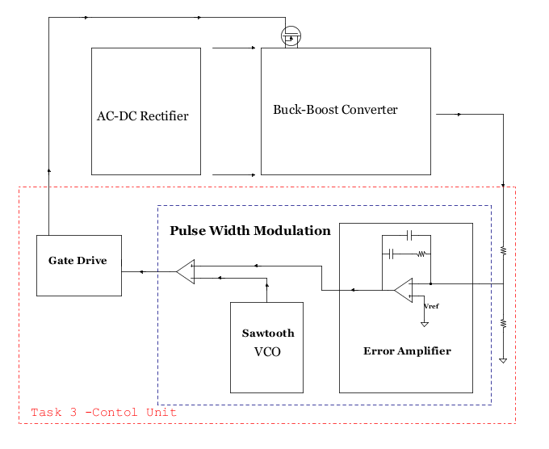

1. Output voltage Simulation

### Subtask 1. Design of The Error Amplifier

In this design, an operational amplifier commonly known as a type II Compensator will be used. Offering an origin pole, one zero, and one high-frequency pole, the Type II compensator provides a phase boost up to 90 degrees. Figure 15.1 shows the electrical configuration, and the transfer function is obtained by calculating the impedance offered by the network placed in the Op-Amp feedback path (Zf) and dividing it by the upper resistor (R1).

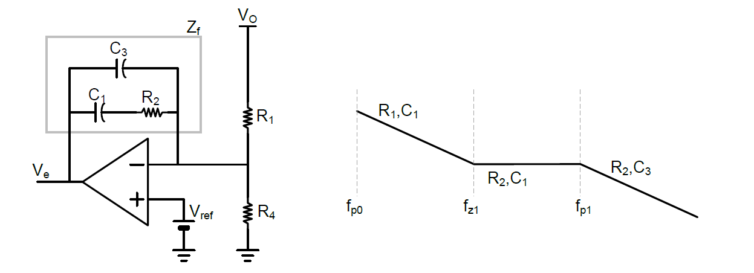

1. Type II Compensator with Gain Curve of Op-Amp

$$H\left(s\right)=\frac{Z_{f}}{Z_{i}}=\frac{\frac{(\frac{1}{sC1}+R2)\frac{1}{SC3}}{(\frac{1}{sC1}+R2)+\frac{1}{sC3}}}{R1}$$

Therefore by rearranging this equation, we get the transfer function:

$$H\left(s\right)=\frac{1+C_{1}R_{2}S}{\left(C_{3}+C_{1}\right)R_{1}S+R_{1}C_{1}C_{3}R_{2}S^{2}}$$

Where the poles and zeros of the transfer functions are listed below:

$$fp1= \frac{1}{ 2π×R2×C3 }$$

$$fz1 = \frac{1}{ 2π×R2×C1 }$$

The transient response will be improved for this design because, in this circuit, the compensator is designed with high bandwidth. With the voltage ripple at the output of the compensator (which is considered the control signal), both the static and the dynamic behaviors of the power supply change in comparison with no voltage ripple case.

Designing of compensator with wide bandwidth results in a fast transient response in power supply. It leads to appreciable voltage ripple on the control signal. The static behavior with appreciable voltage ripple in the output voltage loop is analyzed by using two parameters. [5] Those are the amplitude of the relative voltage ripple on the control signal and its phase lag angle. These two parameters do not vary with the load. But it depends on the total power processed by the converter.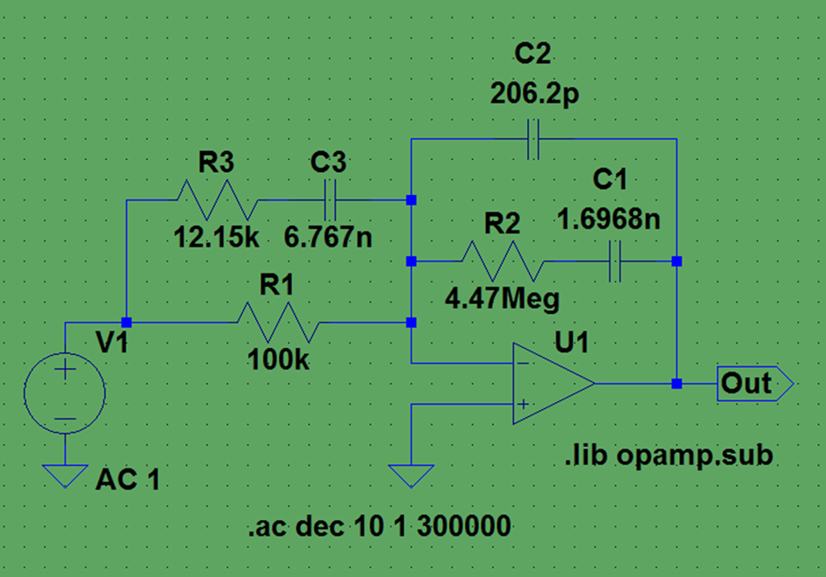

1. Schematics of the error amplifier

If the output voltage deviates from its target, for instance, it increases, the error signal must reduce to instruct the converter to diminish its output. On the contrary, if the output voltage stays below the target, the error voltage will increase to let the converter know that there is a demand for more output voltage. The control action consists of opposing the variation observed in the regulated output of the buck-boost converter.

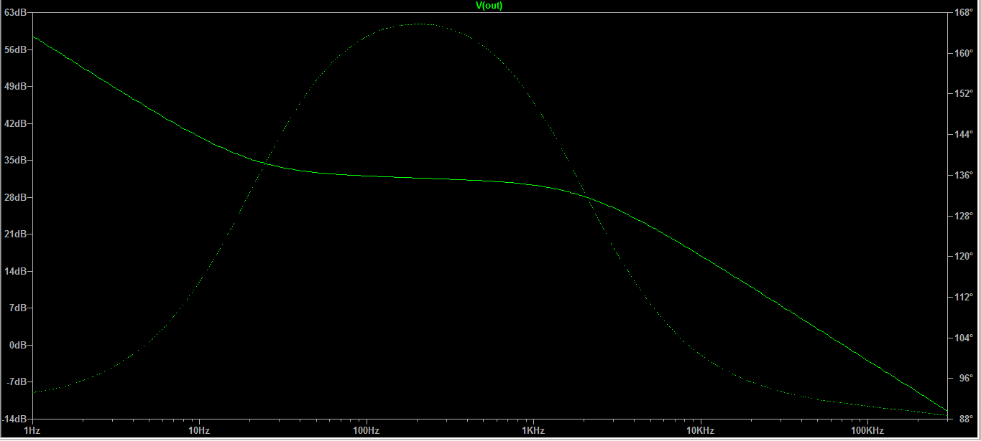

1. The output result of the error amplifier Simulation

Thus, given the error amplifier, calculations for the parameters of the pulse width modulation and voltage controlled oscillator are done in the below equations

$$p_{i,2} = -\left(\frac{1}{2RC}+\frac{r}{2L_{e}}\right) ± \sqrt{{\left(\frac{1}{2RC}+\frac{r}{2L_{e}}\right)}^{2} - \frac{1}{L_{e}C}}$$

Now let,

$$\begin{matrix}a_{1} & \text{=} & \left(rC-\frac{{DL}_{e}}{R}\right) \\ a_{2} & \text{=} & \left(\frac{{rDL}_{e}C}{R}\right) \\ b_{1} & \text{=} & \left(\frac{1}{RC}+\frac{r}{L_{e}}\right) \\ b_{2} & \text{=} & \frac{1}{L_{e}C} \\ k_{1} & \text{=} & \frac{V_{in}}{L_{e}C{\left(1-D\right)}^{2}}\end{matrix}$$

Therefore,

$$\frac{\tilde{v_{o}}}{\tilde{d}} = k_{1}\left(\frac{1 + sa_{1} - s^{2}a_{2}}{s^{2} + sb_{1} + b_{2}}\right)$$

Hence,

$$\frac{\tilde{v_{o}}\left(jω\right)}{\tilde{d}\left(jω\right)} = k_{1}\left(\frac{\left(1+a_{2}ω^{2}\right) + jωa_{1}}{\left(b_{2}-ω^{2}\right) + jωb_{1} }\right)$$

Therefore,

$$\frac{\tilde{v_{o}}\left(jω\right)}{\tilde{d}\left(jω\right)} = k_{1}\left(\frac{\left[\left(1+a_{2}ω^{2}\right)\left(b_{2}-ω^{2}\right)+a_{1}b_{1}ω^{2}\right] + jω\left[a_{1}\left(b_{2}-ω^{2}\right)-b_{1}\left(1+a_{2}ω^{2}\right)\right]}{{\left(b_{2}-ω^{2}\right)}^{2} + ω^{2}b_{1}^{2} }\right)$$

Finally,

$$\begin{matrix}\left|\frac{\tilde{v_{o}}\left(jω\right)}{\tilde{d}\left(jω\right)}\right| & \text{=} & k_{1}\left(\frac{\sqrt{{\left[\left(1+a_{2}ω^{2}\right)\left(b_{2}-ω^{2}\right)+a_{1}b_{1}ω^{2}\right]}^{2} + ω^{2}{\left[a_{1}\left(b_{2}-ω^{2}\right)-b_{1}\left(1+a_{2}ω^{2}\right)\right]}^{2}}}{{\left(b_{2}-ω^{2}\right)}^{2} + ω^{2}b_{1}^{2} }\right) \\ ∢\left(jω\right) & \text{=} & \tan^{-1}\left(\frac{ω\left[a_{1}\left(b_{2}-ω^{2}\right)-b_{1}\left(1+a_{2}ω^{2}\right)\right]}{\left[\left(1+a_{2}ω^{2}\right)\left(b_{2}-ω^{2}\right)+a_{1}b_{1}ω^{2}\right]}\right)\end{matrix}$$

$$\begin{matrix}ω_{reson} & = & 1897 radian frequency \\ f_{reson} & = & 302 Herz\end{matrix}$$

The selected crossover frequency and Power Supply response is,

$\begin{matrix}ω_{c} & = & 4000 radians \\ f_{c} & = & 637 Herz \\ {\left|G_{PS}(s)\right|}_{f_{c}} & = & 51.5 dB \\ {\left.∠G_{PS}(s)\right|}_{f_{c}} & = & -137.12°\end{matrix}$

Let,

$$ϕ_{PM}=60°$$

Therefore,

$$\begin{matrix}ϕ_{boost} & = & -90+ϕ_{PM}-{\left.∠G_{PS}(s)\right|}_{f_{c}} \\ & = & -90+60+137.12 \\ & = & 107.12°\end{matrix}$$

Let,

$$d\left(t\right)=\frac{v_{c}(t)}{\hat{V_{r}}}$$

Therefore,

$$\begin{matrix}\hat{V_{r}} & = & \frac{v_{c}(t)}{d(t)} \\ & = & \frac{2.85}{0.626} \\ & = & 4.55 volts\end{matrix}$$

$$\begin{matrix}{\left|G_{PWM}(s)\right|}_{f_{c}} & = & \frac{1}{{\hat{V}}_{r}} & = & 0.2197 \\ k_{FB} & = & 0.01 & & \end{matrix}$$

Hence,

$$\begin{matrix}{\left|G_{C}(s)\right|}_{f_{c}}×{\left|G_{PWM}(s)\right|}_{f_{c}}×{\left|G_{PS}(s)\right|}_{f_{c}}×k_{FB} & = & 1 \\ {\left|G_{C}(s)\right|}_{f_{c}}×0.2197×375.84×0.01 & = & 1 \\ {\left|G_{C}(s)\right|}_{f_{c}} & = & 1.21\end{matrix}$$

Therefore,

$$\begin{matrix}K_{boost} & = & tan\left(45°+\frac{ϕ_{boost}}{4}\right) \\ & = & tan\left(45°+\frac{107.12°}{4}\right) \\ & = & tan⁡(71.78°) \\ & = & 3.0379\end{matrix}$$

The controller poles and zeros are,

$$\begin{matrix}f_{z} & =\frac{f_{c}}{K_{boost}} & = & 209.68Hz \\ f_{p} & =K_{boost}f_{c} & = & 1.935KHz\end{matrix}$$

The controller gain is

$$k_{c}={\left|G_{C}(s)\right|}_{f_{c}}\frac{ω_{z}}{K_{boost}}=5254.6$$

Let,

$$R_{1}=100KΩ$$

Therefore,

$$\begin{matrix}C_{2} & = & \frac{ω_{z}}{\left(k_{c}ω_{p}R_{1}\right)} & = & 206.2pF \\ C_{1} & = & C_{2}\left(\frac{ω_{p}}{ω_{z}}-1\right) & = & 1.6968nF \\ R_{2} & = & 1/{\left(ω_{z}C_{1}\right)} & = & 4.47MΩ \\ R_{3} & = & {R_{1}}/{\left({ω_{p}}/{ω_{z}}-1\right)} & = & 12.15KΩ \\ C_{3} & = & 1/{\left(ω_{p}R_{3}\right)} & = & 6.767nF\end{matrix}$$

### Subtask 2. Design of Pulse Width Modulation

The voltage-controlled pulse-width modulation (PWM) provides high performance, low noise, and robust operation and hence, it is a very common control method for buck converters. In this method, an Error Amplifier with a Type II compensation network was used as the controller. The non-inverting input of the Error Amplifier is directly connected to the reference signal. To enhance the tracking performance of the PWM voltage controlled buck converter, an op-amp, and a 555timer network is used as a voltage controlled oscillator (VCO). A VCO is a widely used electronic oscillator where the input tuning voltage determines the oscillation frequency. The output frequency of the voltage controlled oscillator is either sinusoidal or sawtooth, in this case, it is a sawtooth.

The 555 timer requires a power supply voltage of 4.5-16V. It is connected to the VCC pin, (15V) and connected GND pin to ground. The reset pin is there to restart the 555 timer's timing operation. This is an active low input, just like the trigger input. Thus, it must be connected to the supply voltage of the 555 timer to operate. If it is momentarily grounded, the 555 timer's operation is interrupted and won't start again until it's triggered again via trigger pin.

The threshold pin’s purpose is to monitor the voltage across the capacitor that's discharged by the discharge pin. When this voltage reaches 2/3 of the supply voltage (VCC), the timing cycle ends, and the output pin goes low.

The trigger pin works like a starter pistol to start the 555 timer running, it is an active low trigger, which means that the timer starts when the voltage on pin 2 drops to below 1/3 of the supply voltage. In this circuit, the trigger pin and threshold pin are connected to the negative input of the comparator.

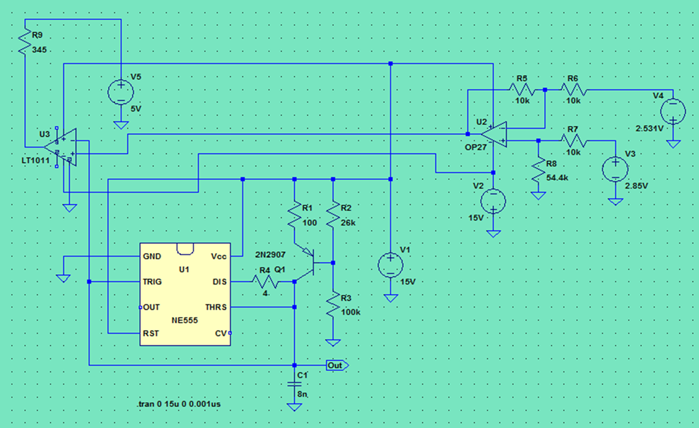

1. Voltage controlled oscillator (VCO)

Figure19. The comparator generated a pulse-width-modulation (PWM) waveform with a duty cycle that is inversely proportional to the input voltage. The 555 timer generates a triangular waveform which is passed to the inverting input of the comparator. By passing the input voltage to the non-inverting comparator input, a PWM waveform is produced.

For a Voltage controlled oscillator generating a sawtooth waveform, the main component is the capacitor who’s charging and discharging actually decides the formation of the output waveform. The input is given in form a voltage which can be controlled. This voltage is converted to a current signal and is applied to the capacitor. As the current passes through the capacitor, it starts charging and a voltage starts building across it. As the capacitor charges and the voltage across it increase gradually, the voltage is compared with a reference voltage using a comparator.

When the capacitor voltage exceeds the reference voltage, the comparator generates a high logic output which triggers the transistor and the capacitor is connected to ground and starts discharging. Thus the output waveform generated is the representation of the charging and discharging of the capacitor and the frequency is controlled by the input dc voltage.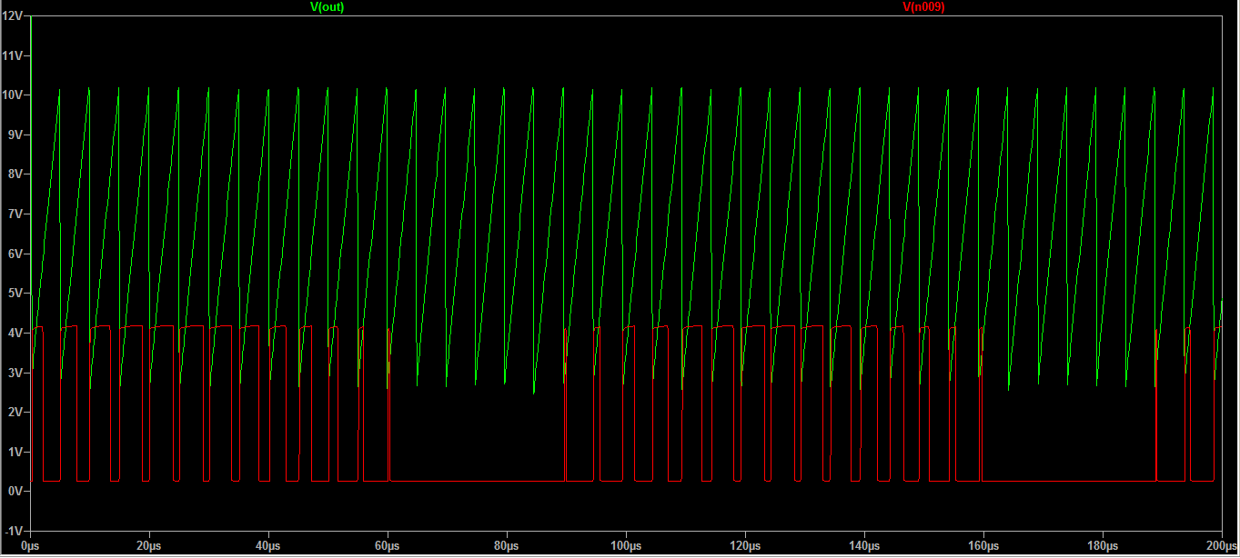

1. Output Simulations output of the VCO generating

### Subtask 3. Design of A Gate drive

In order for this system to operate it needs of a switch that can handle significant power levels to be able to work correctly. Since there are no ideal switches, the component was chosen for this task is a metal oxide semiconductor field-effect transistor (MOSFET) and for high frequencies, MOSFETs require a gate drive circuit to do the on/off operation at the desired frequency.

Figure15 shows a level shifted gate drive circuit that is suitable for the high-speed application and works seamlessly with the PWM. The open collector level shift principle can be easily recognized at the input of a bipolar driver stage. The level shifter serves two purposes in this implementation; it inverts the PWM output and references the PWM signal to the input rail.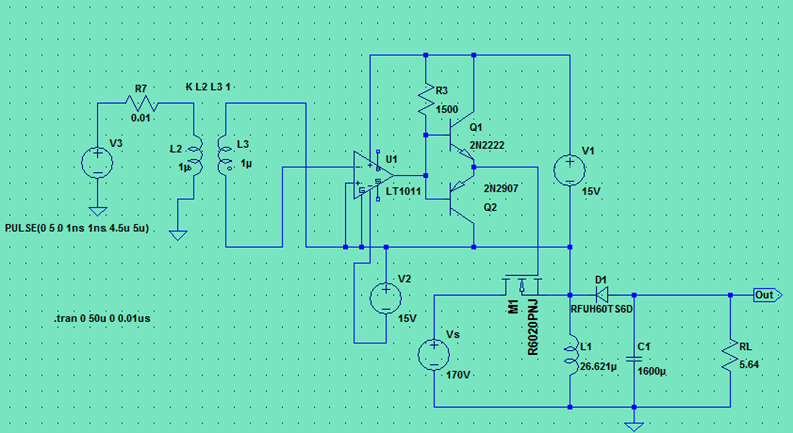

1. Design of the gate drive

The turn-on speed is fast, defined by GATE and R3. During the on-time of the switch, a small DC current flows in the level shifter keeping the driver biased in the right state. Both the gate drive power and the level shift current are provided by the positive input of the power stage

The power consumption of the driver has a frequency dependent portion based on the gate charge of the main switch and a duty-cycle and the input voltage dependent portion due to the current flowing in the level shifter

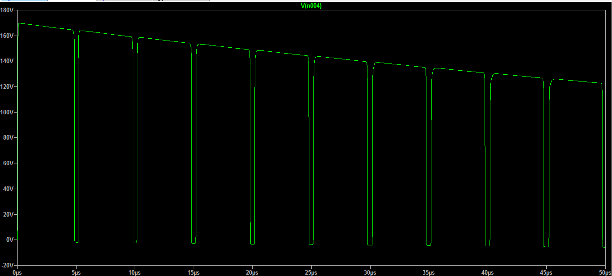

1. Simulation Output of the gate drive

## Implementation of Task 5: Simulation of the Full Circuit

The system is designed to generate a 14.4-kilowatt power supply that will operate on both single phase and three phase inputs, with emphasis on cost and reliability. The current generation of self-configuring power supplies is implemented with input rectifier stage to enable the system to operate on most of the North American single and three phase line voltage standards. The self-configuration feature of this design automatically configures the input power subsystem to allow the power supply to operate on 120-240 volts single phase or 240, 380,415 and 575-volt three-phase power line. The reconfigurable input block power transmission matrix is implemented with a metal-oxide-semiconductor-field-effect transistor (MOSFET) switch. The full circuit and simulation is shown below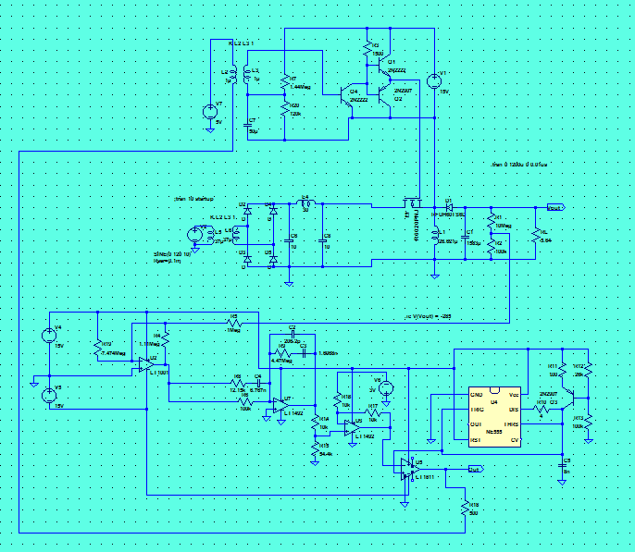

1. Systems’ circuit

When a transistor is switched on or off, it does not immediately switch from a non-conducting to a conducting state; and may transiently support both a high voltage and conduct a high current. Consequently, when gate current is applied to a transistor to cause it to switch, a certain amount of heat is generated which can, in some cases, be enough to destroy the transistor. Therefore, it is necessary to keep the switching time as short as possible, so as to minimize switching loss.

Typical switching times are in the range of microseconds. The switching time of a transistor is inversely proportional to the amount of current used to charge the gate. Therefore, switching currents are often required in the range of several hundred milli-amperes, or even in the range of amperes. For typical gate voltages of approximately 10-15V, several watts of power may be required to drive the switch. When large currents are switched at high frequencies in DC-to-DC converters or large electric motors, multiple transistors are sometimes provided in parallel, so as to provide sufficiently high switching currents and switching power [12].

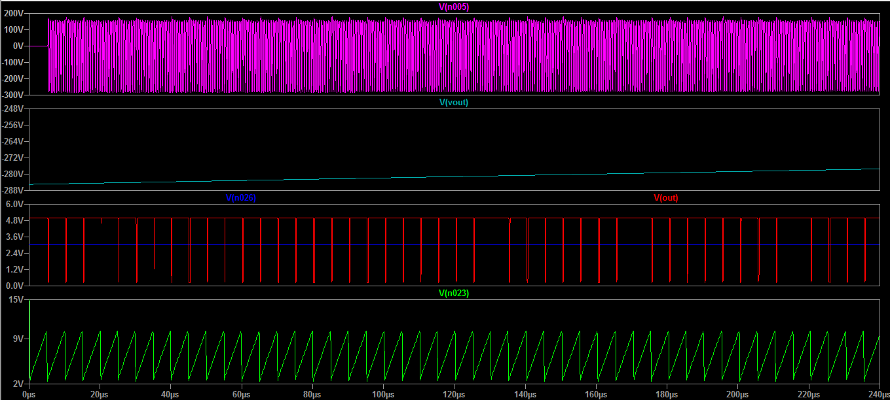

1. Simulation Output of the system

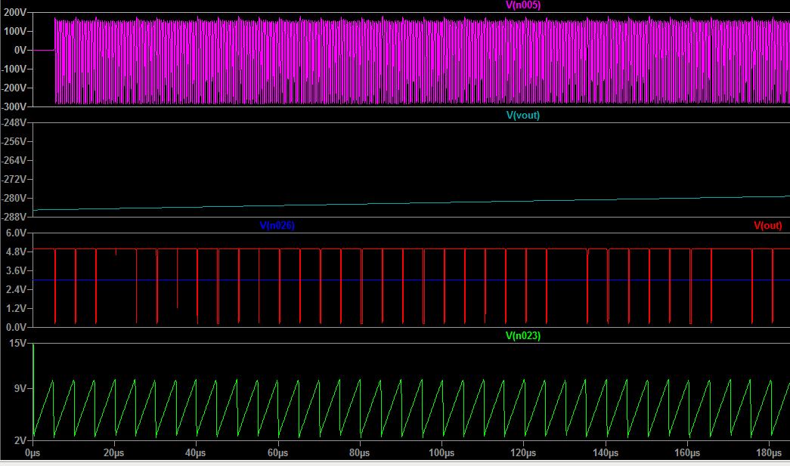

1. Zoomed-in simulation Output of the system

## Implementation of Task 6: System Design Verification

After completion of the entire circuit design based on the parameters defined earlier in the design requirement, we re-ran the simulation again and proved to work as designed to be. However, due to the budgetary constraints, it was determined its best scale down the design capacity in terms of the load current from fifty amperes to five amperes which would greatly decrease the cost and size of some materials. The detailed bill of materials is displayed in the next implementation task.

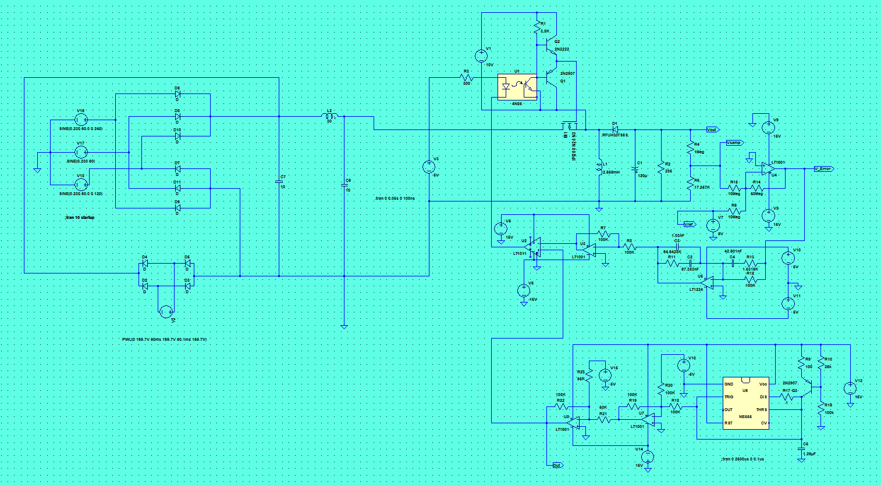

1. Reviewed schematics with the addition of the three phase and single phase

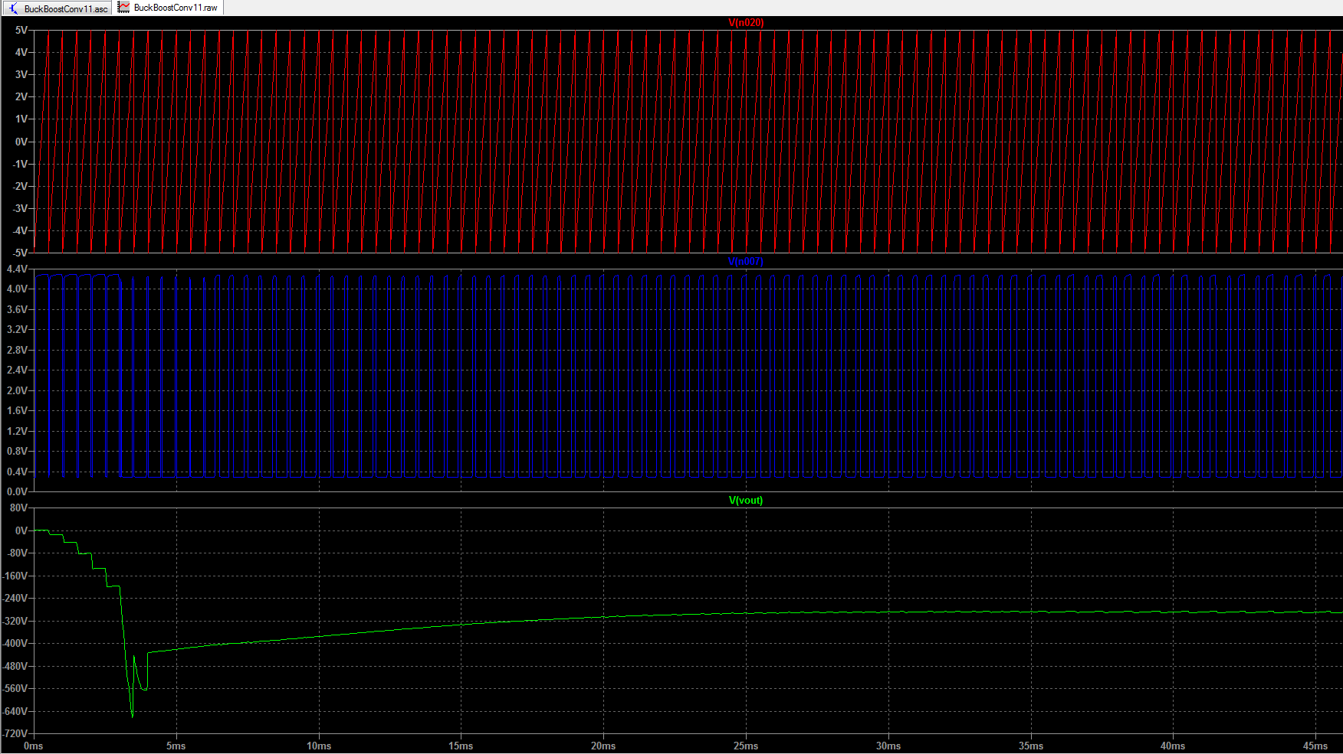

1. Simulation results

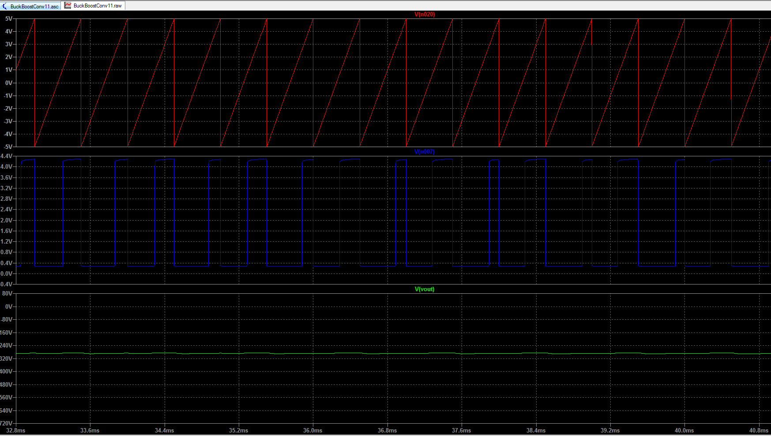

1. Zoomed in the output of the circuit simulation

The single phase and three phases are dually connected in a forwardly biased configuration; they’re not designed to work simultaneously because the circuit can only take one input at a time. When the single phase is on/ plugged in, the tree phase is off/not connected to any source. This would work vice versa.

Further analysis and simulations were done using the Texas Instrument’s Power Stage Designer Tool to generate the gain information, poles and zeros as well as confirm the changes observed due to the change in the load current and maximum input voltage which was initially 600v and now is 400v.

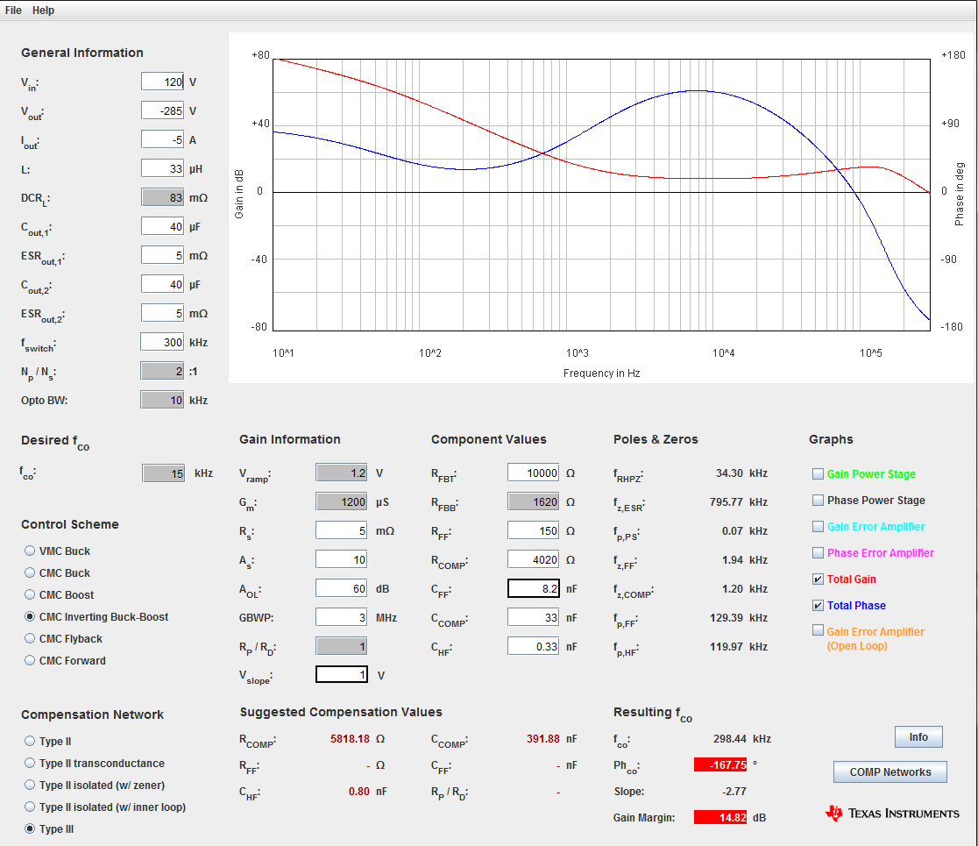

1. Loop calculator Results

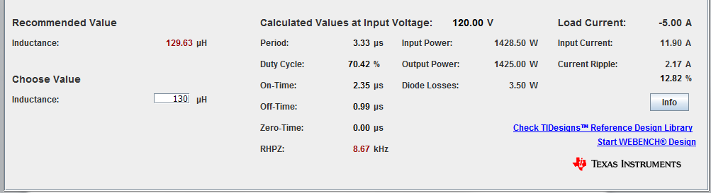

1. Recommended values for the buck-boost design

## Implementation of Task 7: Analyzing and Compiling Materials Needed

The table below shows the list of materials its cost that we plan to purchase during the development of the power supply circuit. The prices listed are of current and might change at the time of purchase. To reduce the cost, certain items were not included on the list because they are either available in some of our engineering labs or can be easily found on campus. The bill of materials can be found under the appendix. For your information, taxes and shipping cost are not included.

## Implementation of Task 8: Design of The PCB

Due to budgetary constraints, I’m using some very affordable and free software available online service called EasyEDA and Eagle to design a PCB layout for this power supply circuit which I’ll then have it manufactured by a professional manufacturer. Here is the process is taken to accomplish this task. Re-drawing the schematic

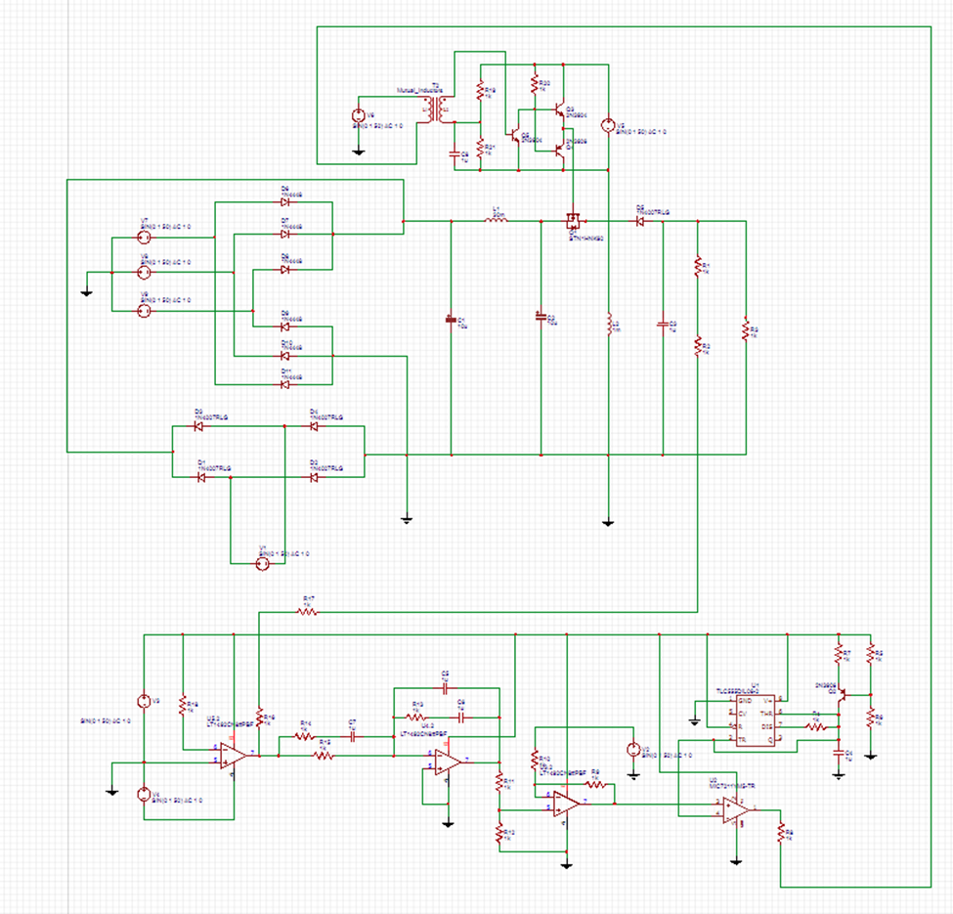

1. Full schematic of the power supply

Before you start the PCB design I had the schematic of my circuit in LTSpice, therefore I had to redraw the schematic in EasyDA and Eagle. Having the schematic here serves as a blueprint for laying out the traces and placing the components on the PCB. The PCB editing software can import all of the components, footprints, and wires into the PCB file, which will make the design process easier. After all the wiring is done the next step was to import the schematic into the PCB editor

### Importing the Schematic into the PCB Editor

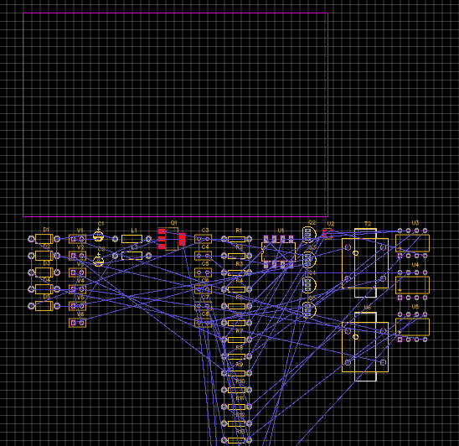

1. The software’s generic PCB editor

In order to reorganize the circuit, it was helpful to draw some diagrams at this point to help me visualize the design before you start laying it out. The circuit is divided into sections according to function. This circuit has four main sections: a single and three phase rectifier, a buck-boost converter, the feedback control, and transistor drive. It is advised to keep the components in each section grouped together in the same area of the PCB to keep the conductive traces short because long traces can pick up electromagnetic radiation from other sources, which can cause interference and noise.

### Creating PCB and Layout

* Layer Thickness

Both software has restrictions on layer thicknesses of two ounces. Copper weight is the term manufacturers use to describe the layer thickness, and it’s measured in ounces. The thickness of a layer will affect how much current can flow through the circuit without damaging the traces. Trace width is another factor that affects how much current can safely flow through the circuit [4.6]. To determine safe values for width and thickness needed, one has to know the amperage that will flow through the trace in question. In this case, it’s 5A flowing through the traces and I used an online PCB trace calculator (the calculator.com) to determine the ideal trace thickness and width for a 5 Amps.

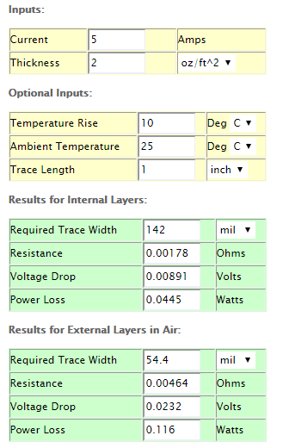

1. Online calculator that was used

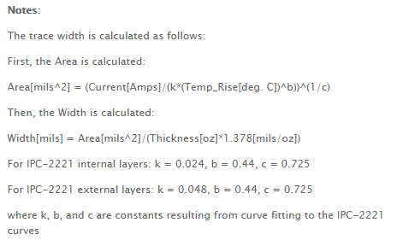

1. Formulas used to obtain the parameters

* Routing

The different sections of the circuit are arranged so the path of electrical current is as linear as possible. The signals in the circuit should flow in a direct path from one section to another, which will keep the traces shorter. After arranging all of the components, it was time to start drawing the traces using the rat's nest wires as a rough guide. (Ratsnest are the thin blue lines connecting the components seen in the previous image. The lines are virtual wires that represent the connections between components.)

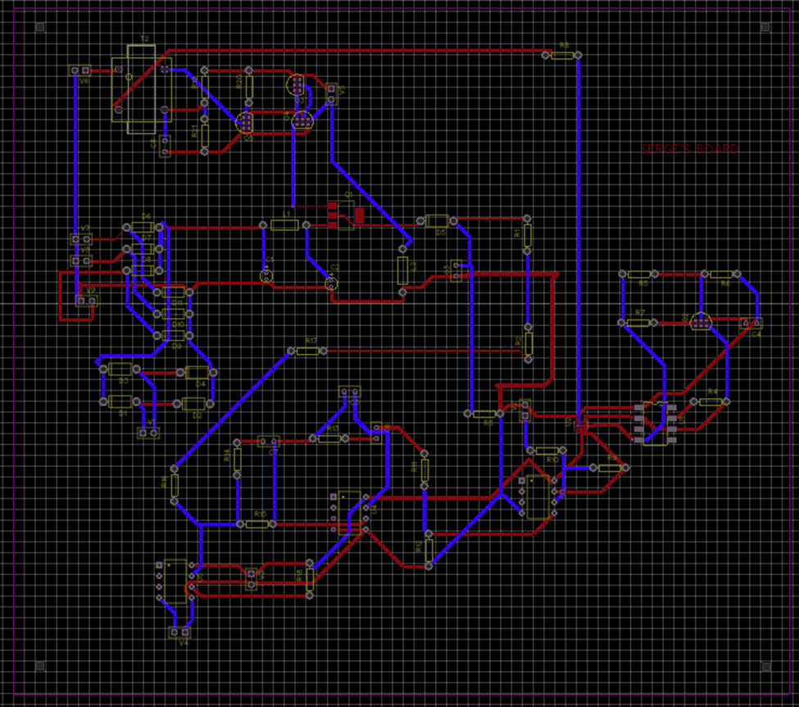

1. Drawing the traces

* Trace Width

Like layer thickness, the width of the traces affects how much current can flow through the circuit without causing any damages to it. The proximity of traces to components and adjacent traces also determined how wide the traces would be. Because I am designing a small PCB with lots of traces and components, the traces had to be a bit narrow for everything to fit. (Of course with consideration of the parameters generated by the online calculator) with 5 Amps and thickness of 2 Oz, the trace width was set to 142 mil which was way too wide for the small board given the number of components. Thus it was scaled down to 1.5A, 2 Oz and 30mil width to accommodate the circuit.

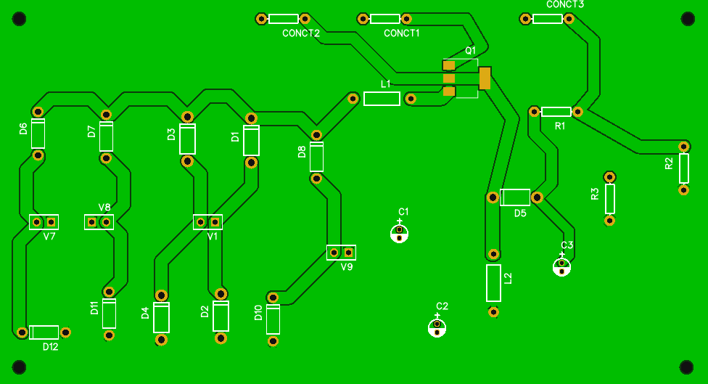

1. The final look of the board 1

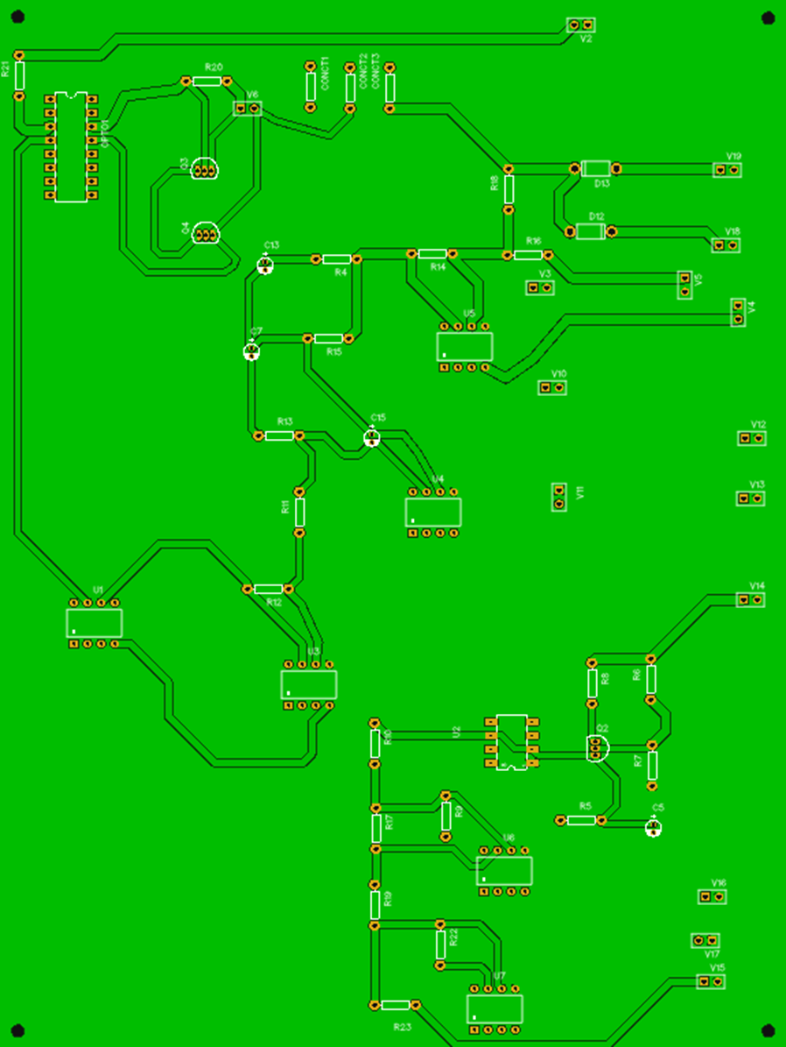

1. The final look of the board 2
2. Hardware Assembly and Testing

The full layout of the boards is shown in the images below, including traces and designated component placements. In addition to the two-layer constraint, there was also a significant size reduction in order to cut down the cost of manufacturing. This meant that larger components such as the heatsinks, huge capacitors and the inductors could not be placed on the board. This resulted in substituting the 40uF capacitor with 20uF and completely not using the heat sinks. To help with ground loops, copper pours were placed on bottom layer of the board; tied to ground and connected through, this meant that ground connections should be low resistance and close to all components as needed.

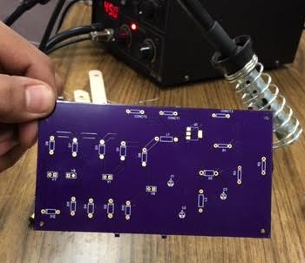 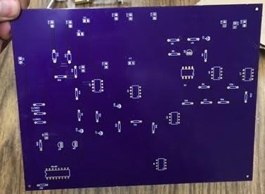

1. Received boards from the manufucturer

Component selection was heavily influenced by the size of the board and even with larger

Components, many footprints were situated close together. After the layout and Gerber files were sent to the manufacturer, it became apparent that the main transistor had the wrong footprint, meaning it could not be soldered onto the board. All components are through-hole/pin mounted devices except for the main MOSFET for the DC-DC Converter which is a surface mount. In industry, it would be typical to do a re-spin of the PCB and put the assembly on hold until the fixed layout was available; however this was not an option due to time constraints and feasible alternative solutions. Because of the some large components and tight arrangement, and in addition to the materials used by the manufacture, assembling became challenging as it was not anticipated. The board was sort of greasy and the solder would not stick pretty well. Furthermore, the pads weren’t wide enough as the diameter was 74mil (Not the manufacturers’ fault but a mishap from us as we used the default setting from the PCB design).

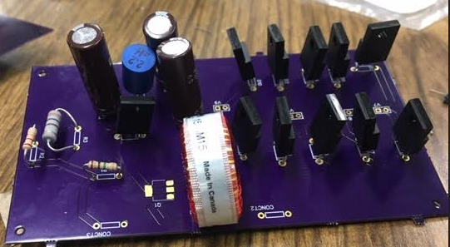

1. Soldering components on PCB1

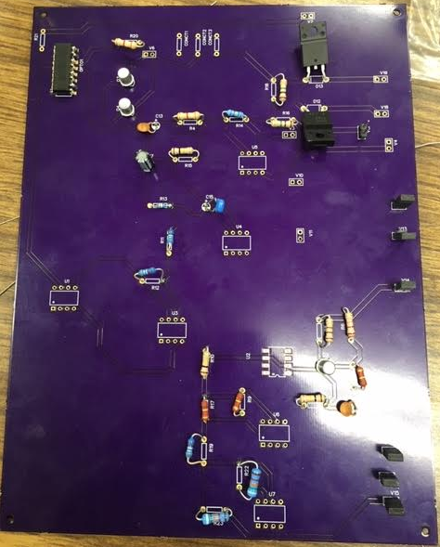

1. Soldering components on PCB2

The system testing was not performed to see if it could meet the design requirements due to various reasons. There were lack of equipment to test those conditions specified in the design requirements and some components mismatches. For instance, the printable circuit board layout for the main MOSFET for the DC-DC Converter was a surface mount as opposed to through-hole one, also we could not mount the heatsinks in place because the circuit board wasn’t big enough to accommodate them, hence running a test would put the circuit in risk of overheating as well as jeopardize our safety. In addition, we did not have enough operational amplifiers in our lap to complete the circuit soldering. Given these circumstances and after putting all things into consideration it was impossible to conduct a test.

1. Conclusion.

This design report document compiles all the research, mathematical analysis, design approach and implementation of tasks as well as simulations completed during this project and up to the end of the Senior Design II; also known as ENGE 476. As specified in the objective and design requirement sections, the goal of this project was to design an AC-DC power supply that takes a wide range of AC input voltages to supply a steady DC voltage to a welder's inverter circuit. Overall the project was successful; the goals were achieved through calculations and proven in the system’s simulations. While much more testing for the prototype is required, this senior project created a solid foundation for a young aspiring engineer to fully understand the concept of power electronics and the steps of designing a functional product.

Acknowledgment

Over the course of this project, Dr. Walker provided significant assistance. Alvernon Walker Ph.D. is a wonderful electrical engineering professor in our department, his help involved assistance in research, concept development, troubleshooting, and general advice on books to read and how to use the knowledge acquired in classrooms to best complete the project. Without Dr. Walker, the project would not have been accomplished in this manner.

Appendix

Table2. List of Materials Needed and Cost

|  |  |  |  |  |  |  |
| --- | --- | --- | --- | --- | --- | --- |
| **Part** | **Description** | **Part #** | **Vendor** | **Quantity** | **Unit Price** | **Total Price** |
| Diodes | 10 Amps Diodes | DPG10I300PA | Mouser Electronics | 30 | $1.17 | $34.8 |
| MOSFET | Power transistor | STP12N50M2 | Mouser Electronics | 5 | $2.33 | $11.65 |
| BJT | transistor | 2N2222 | Mouser Electronics | 10 | $2.03 | $18.00 |
| 555 timer | Saw tooth gen | NE555P | Mouser Electronics | 5 | $0.43 | $2.30 |
| Heat sink | Heat sink | 34UJ46 | Digi-Key | 5 | $10.86 | $54.45 |
| PCB | PCB |  | JLCPCB | 5 |  | $80 |
|  |  |  |  |  |  |  |
| Inductor | 5A,33UH |  | Mouser | 5 | $4.63 | $19.95 |
| Inductor |  | 434-TLC/10A-330M-00 |  | 5 | $2.00 | $10.00 |
| Resistors | 100K ohms | RNF14BTE100K | Digi-Key | 10 | $0.49 | $4.91 |
|  | 1.4Meg ohms | ‎PPCHF1.40MCT-ND‎ | Digi-Key | 10 | $0.935 | $5.70 |
|  | 4.75Meg ohms | CF14JT4M70‎ | Digi-Key | 10 | $0.10 | $10.00 |
| Transformer |  |  |  |  |  |  |
| Capacitors | 40uF, 450V | 75-TVA1712 | Mouser | 5 | $13.92 | $69.70 |
|  | 10uF, 500V | 661-EKXJ501ELL100MJ3 | Mouser | 5 | $1.09 | $5.45 |
|  | 0.2uF, 100v | 647-UVR2AR22MDD1TD | Mouser | 5 | $0.17 | $0.85 |
|  | 1.69uF, 400v | 647-ULD2G1R5MPD6 | Mouser | 5 | $0.69 | $3.45 |
|  | 0.6uF | 647-UKL2AR68KDD | Mouser | 5 | $0.38 | $1.90 |
| ** | 1580uF | 539-CG1551U150V4C | Mouser | 2 | $33.28 | $66.56 |
| AMPLIFIER |  | 584-LT1492CS8#PBF | Mouser | 10 | $7.06 | $70.60 |
| Total |  |  |  |  |  | $470.2 |

REFERENCES

[1] A. N. (n.d.). Power, Electronic Systems, Applications, and Resources on Electrical and Electronic Project-Thesis. Retrieved from http://protorit.blogspot.com/2013/02/three-phase-full-wave-controlled-rectifier.html

[2] Home. (n.d.). Retrieved from https://www.pantechsolutions.net/powerelectronics-tutorials/introduction-of-three-phase-half-full-wave-converter

[3] Full Wave Rectifier and Bridge Rectifier Theory. (2018, February 24). Retrieved from https://www.electronics-tutorials.ws/diode/diode_6.html

[4] Sajib Barua "Power, Electronic Systems, Applications and Resources on Electrical and Electronic Project-Thesis," http://protorit.blogspot.com/2013/02/three-phase-full-wave-controlled-rectifier.html.

[5] N. Kirman, M. Kirman, R. K. Dokania, J. F. Martinez, A. B. Apsel, M. A. Watkins*, et al.*, "Leveraging Optical Technology in Future Bus-based Chip Multiprocessors," in *Microarchitecture, 2006. MICRO-39. 39th Annual IEEE/ACM International Symposium on*, 2006, pp. 492-503.

[6] J. M. Cianchetti, C. J. Kerekes, and H. D. Albonesi, "Fastlane: a rapid transit optical routing network," in *Proceeding of 36th International Symposium on Computer Architecture (ISCA)*, 2009, pp. 441-450.

[7] A. Shacham, K. Bergman, and L. P. Carloni, "Photonic Networks-on-Chip for Future Generations of Chip Multiprocessors," *Computers, IEEE Transactions on,* vol. 57, pp. 1246-1260, 2008.

[8] A. Shacham, K. Bergman, and L. P. Carloni, "On the Design of a Photonic Network-on-Chip," in *First International Symposium on Networks-on-Chip, 2007. NOCS 2007*, 2007, pp. 53-64.

[9] M. Kwai Hung, Y. Yaoyao, W. Xiaowen, Z. Wei, L. Weichen, and X. Jiang, "A Hierarchical Hybrid Optical-Electronic Network-on-Chip," in *VLSI (ISVLSI), 2010 IEEE Computer Society Annual Symposium on*, 2010, pp. 327-332.

[10] D. Ding and D. Z. Pan, "OIL: a nano-photonics optical interconnect library for a new photonic networks-on-chip architecture," presented at the Proceedings of the 11th international workshop on System-level interconnect prediction, San Francisco, CA, USA, 2009.

[11] A. Joshi, C. Batten, K. Yong-Jin, S. Beamer, I. Shamim, K. Asanovic*, et al.*, "Silicon-photonic closed networks for global on-chip communication," in *Networks-on-Chip, 2009. NoCS 2009. 3rd ACM/IEEE International Symposium on*, 2009, pp. 124-133.

[12] D. Vantrease, R. Schreiber, M. Monchiero, M. McLaren, N. P. Jouppi, M. Fiorentino*, et al.*, "Corona: System implications of emerging nanophotonic technology," in *Proc. 35th IEEE/ACM Int'l Symp. Computer Architecture (ISCA)*, 2008, pp. 153-164.

[13] L. Zhang, E. Regentova, and X. Tan, "A 2D-Torus Based Packet Switching Optical Network-on-Chip Architecture," presented at the *IEEE International Symposium on Photonics and Optoelectronics* (SOPO 2011), Wuhan, China, 2011.

[14] L. Zhang, E. E. Regentova, and X. Tan, "Packet switching optical network-on-chip architectures," *Comput. Electr. Eng.,* vol. 39, pp. 697-714, 2013.

[15] G. Huaxi, X. Jiang, and W. Zheng, "A novel optical mesh network-on-chip for large-scale systems-on-chip," in *Circuits and Systems, 2008. APCCAS 2008. IEEE Asia Pacific Conference on*, 2008, pp. 1728-1731.

[16] G. Huaxi, X. Jiang, and Z. Wei, "A low-power fat tree-based optical Network-On-Chip for multiprocessor system-on-chip," in *Design, Automation & Test in Europe Conference & Exhibition, 2009. DATE '09.*, 2009, pp. 3-8.

[17] Y. Yaoyao, X. Jiang, H. Baihan, W. Xiaowen, Z. Wei, W. Xuan*, et al.*, "3-D Mesh-Based Optical Network-on-Chip for Multiprocessor System-on-Chip," *Computer-Aided Design of Integrated Circuits and Systems, IEEE Transactions on,* vol. 32, pp. 584-596, 2013.

[18] A. Shacham, K. Bergman, and L. P. Carloni, "Photonic networks-on-chip for future generations of chip multiprocessors," *IEEE Trans. Computers,* vol. 57, pp. 1246-1260, 2008.

[19] A. W. Poon, F. X. Xu, and X. Luo, "Cascaded active silicon microresonator array cross-connect circuits for WDM networks-on-chip," in *Proc. SPIE*, 2008, p. 689812.

[20] M. Lipson, "Compact Electro-Optic Modulators on a Silicon Chip," *IEEE Journal of Selected Topics in Quantum Electronics,* vol. 12, pp. 1520-1526, 2006.

[21] M. Lipson, "Guiding, modulating, and emitting light on Silicon-challenges and opportunities," *Lightwave Technology, Journal of,* vol. 23, pp. 4222-4238, 2005.

[22] T. Xianfang, Y. Mei, Z. Lei, J. Yingtao, and Y. Jianyi, "Wavelength-routed optical networks-on-chip built with comb switches," in *Photonics Conference (IPC), 2013 IEEE*, 2013, pp. 46-47.